Next Gen HNC

Network Infrastructure — J68S 47
SCQF level 7

Logbook

Outcome 1 Tasks | 1. Design a Network Infrastructure | All evidence by Learner.  (Screenshots with description)
Outcome 2 Tasks | 2 Implement a Network Infrastructure | All evidence by Learner.  (Screenshots with description)
Outcome 3 Tasks | 3 Secure a Network Infrastructure. | All evidence by Learner.  (Screenshots with description)
Outcome 4 Tasks | 4 Maintain a Network Infrastructure. | All evidence by Learner.  (Screenshots with description)

Project brief

Telematics Ltd is a new SME based in Central Scotland which supplies Satnav & Tracking devices to a wide range of clients.
The company has a new head office which is due to open in 3 months.
The Managing Director has tasked you with designing and implementing a network for their office. The company requirements are as follows.
- The network must support 12 users
- The network must be centrally controlled and managed.
- The network must be secured against external threats including viruses and hacking
- Secure wireless access to the network is required for BYOD
- The network must be easily maintained

The company has 10 staff members:
1 x Managing Director
3 x Sales Staff
2 x Purchasing staff
1 x Stockroom Staff
1 x HR Manager
2 x Accounts Staff
2 x Receptionist

Documentation/Evidence
Evidence can be produced using various methods/platforms e.g. Azure; Hyper-V; Cisco Packet Tracer; VMWare; Oracle Virtual Box; GNS3.
Documentation can be in the form of an e-portfolio, blog, report or webpage with evidence of completed tasks with appropriate screenshots.

Assessment 2

Outcomes covered: 1 & 2
Implement a Network Infrastructure
Assessment instructions
Scenario — You have been tasked with the setting up and configuring of a small local area network. This network should be set up with an emphasis on securing the endpoints of the network. To comply with this requirement, you can choose any suitable network operating system. You should be provided with suitable working hardware to allow this task to be completed. (Physical or Virtual)

*DISCLAIMER* Due to an issue with my screenshots, I have had to use one of peer’s screenshots. I followed the exact same process and the explanations and captions are my own.

Stage 1 — Select a suitable contemporary network topology and create a Logical Diagram that includes your chosen IP addressing scheme and Justify your choice.
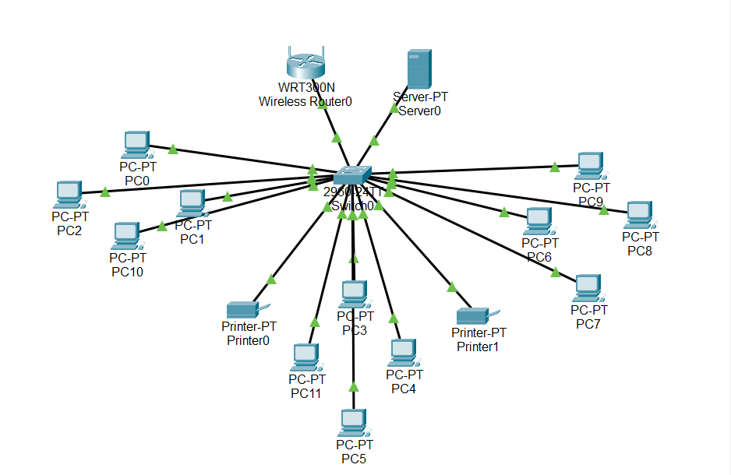
A star topology was selected as it is simple to manage, easy to expand, and allows faults to be isolated quickly. All end devices connect back to a central switch, which in turn connects to the router.

Wired connections use copper Ethernet cabling for reliability and performance, while a wireless router provides flexibility for portable and personal devices.

The IP addressing scheme chosen is 192.168.1.0/24, allowing up to 254 usable IP addresses. As only 14 addresses are initially required, this leaves ample capacity for future expansion and temporary devices such as laptops or mobile phones.

Assessor’s signature |  | Date

Stage 2 — Design the physical topology (Floor Plan) that illustrates the design of your Logical Diagram. (This must show building layout, devices, cabling etc). Describe where the cabling is placed throughout the building and provide a legend for your diagram.

The physical office topology incorporates all required staff workstations, along with shared printers located in each office area, except for the reception area and the server room.

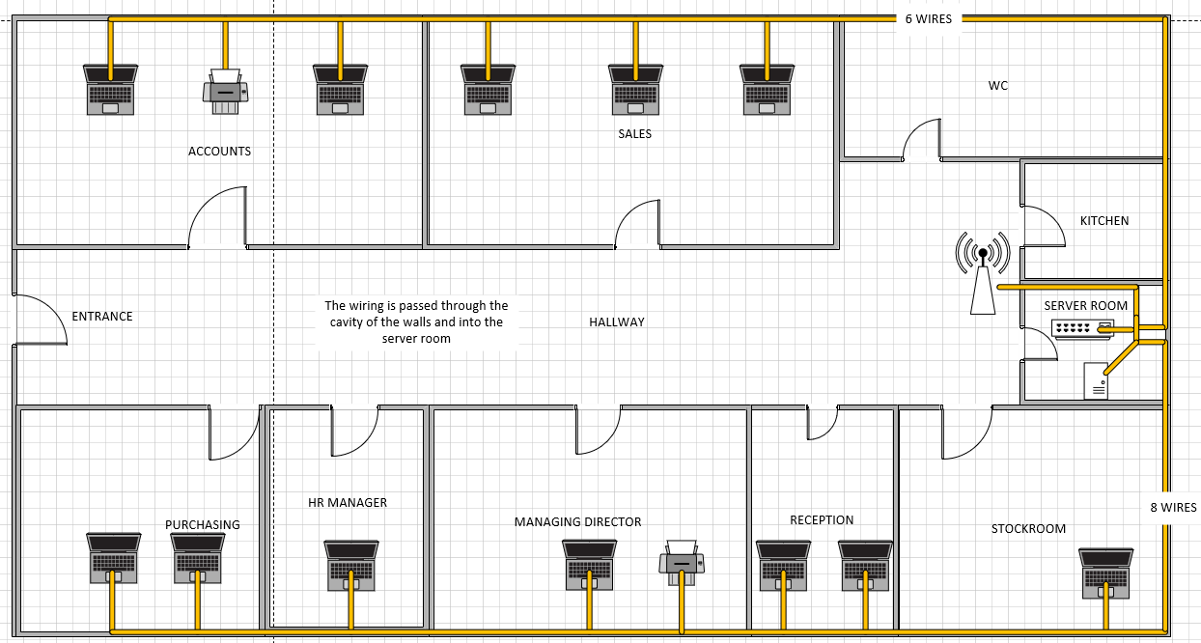
The server room houses the core networking equipment, including the router that provides both wired and wireless connectivity to end devices. It also contains the central switch through which all wired network connections are routed, as well as the server responsible for managing and controlling the local network.

Assessor’s signature |  | Date

Stage 3 — Install Network nodes and Operating Systems.
Configure a (depending on your design) server to be a domain controller. The Domain Name should be your surname.local (e.g. Smith.local). Describe the steps taken to create the domain.

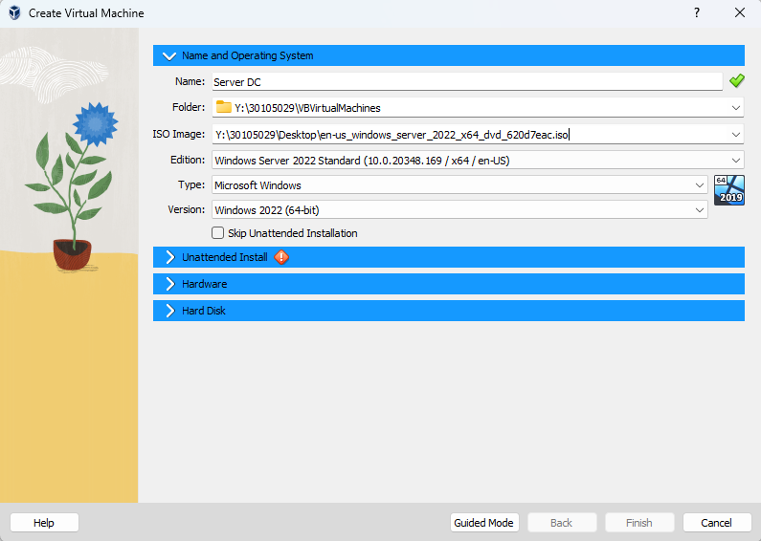
Server OS Installation
Appropriate hardware resources are then allocated to the server, assigning 16 GB of RAM and 4 CPU cores to ensure stable and efficient performance.
The initial step when creating the server in VirtualBox is to select the Windows Server 2022 ISO file supplied by the college.
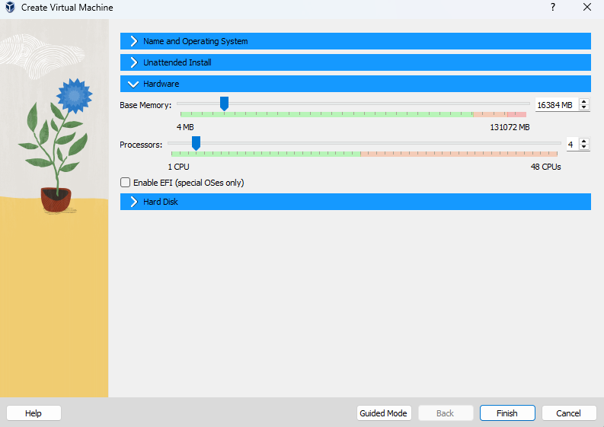

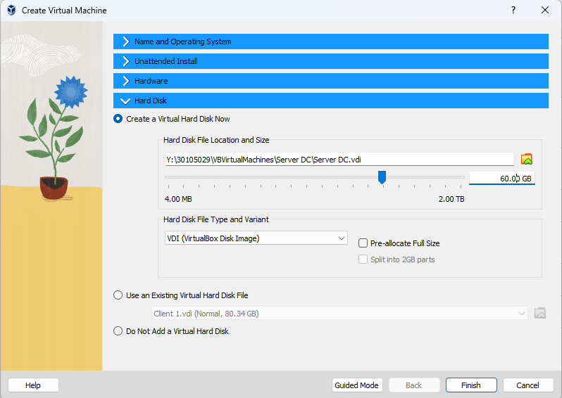
A virtual hard disk is created for the server by allocating 60 GB of storage from the college PC’s SSD to the virtual machine.

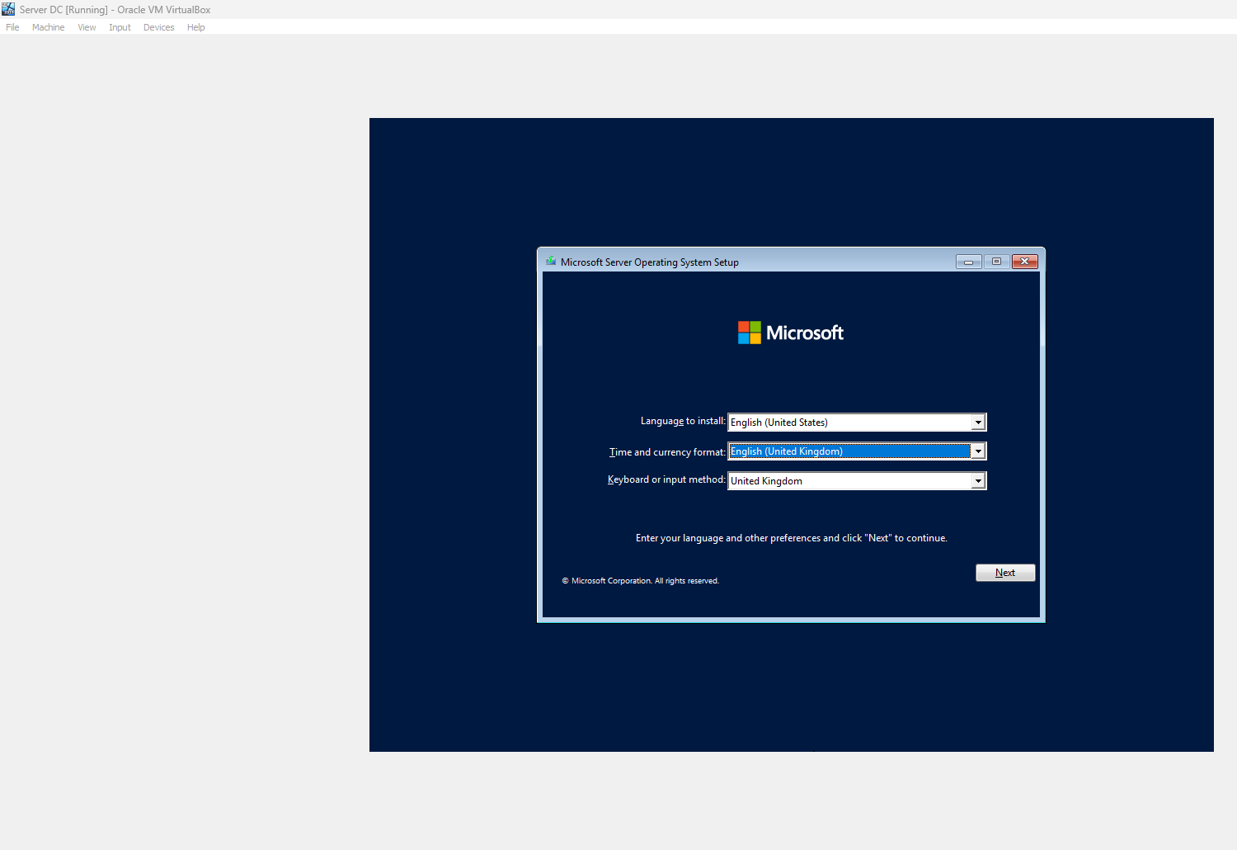
English (United Kingdom) is chosen for the language, time, and currency format.
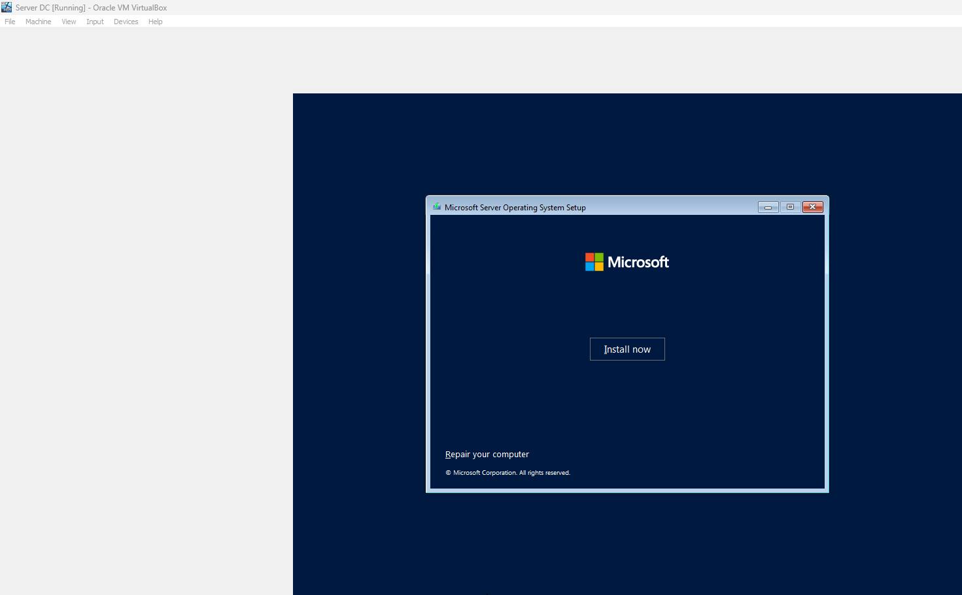
To begin the operating system installation, the Install Now button is selected.

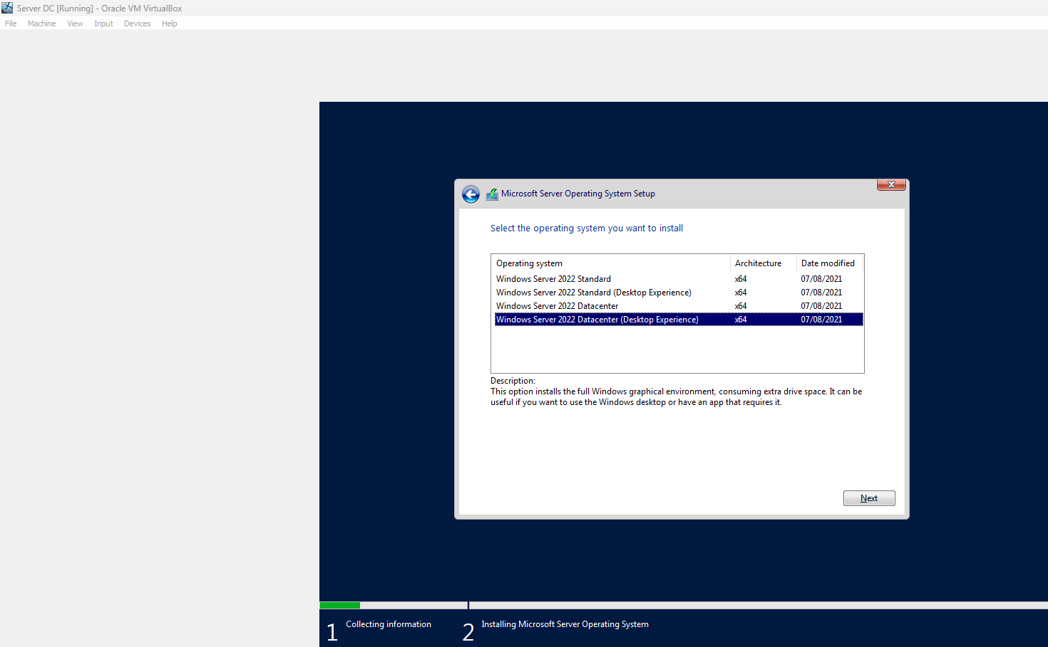
Windows Server 2022 Datacentre is selected as the operating system, and the setup is continued by clicking next. The Desktop Experience edition is chosen as it includes a graphical user interface (GUI).
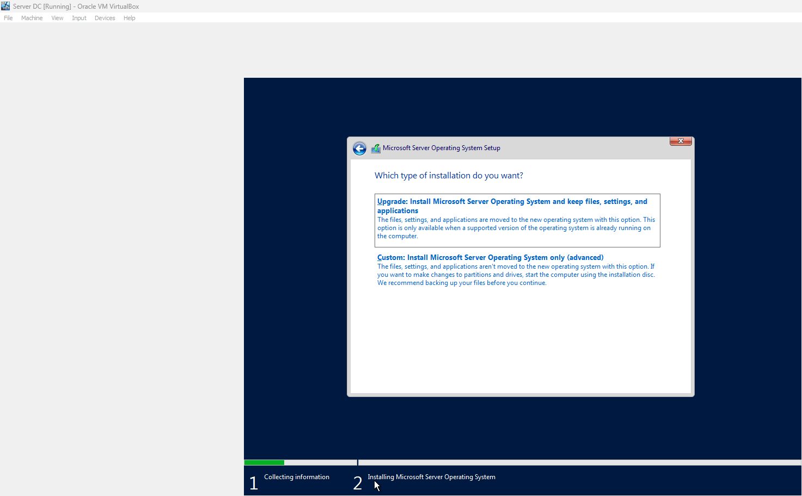
I select Custom Install as this is a completely new install of an OS, as it is a new virtual machine there is no previous operating system to upgrade and keep files and settings from.

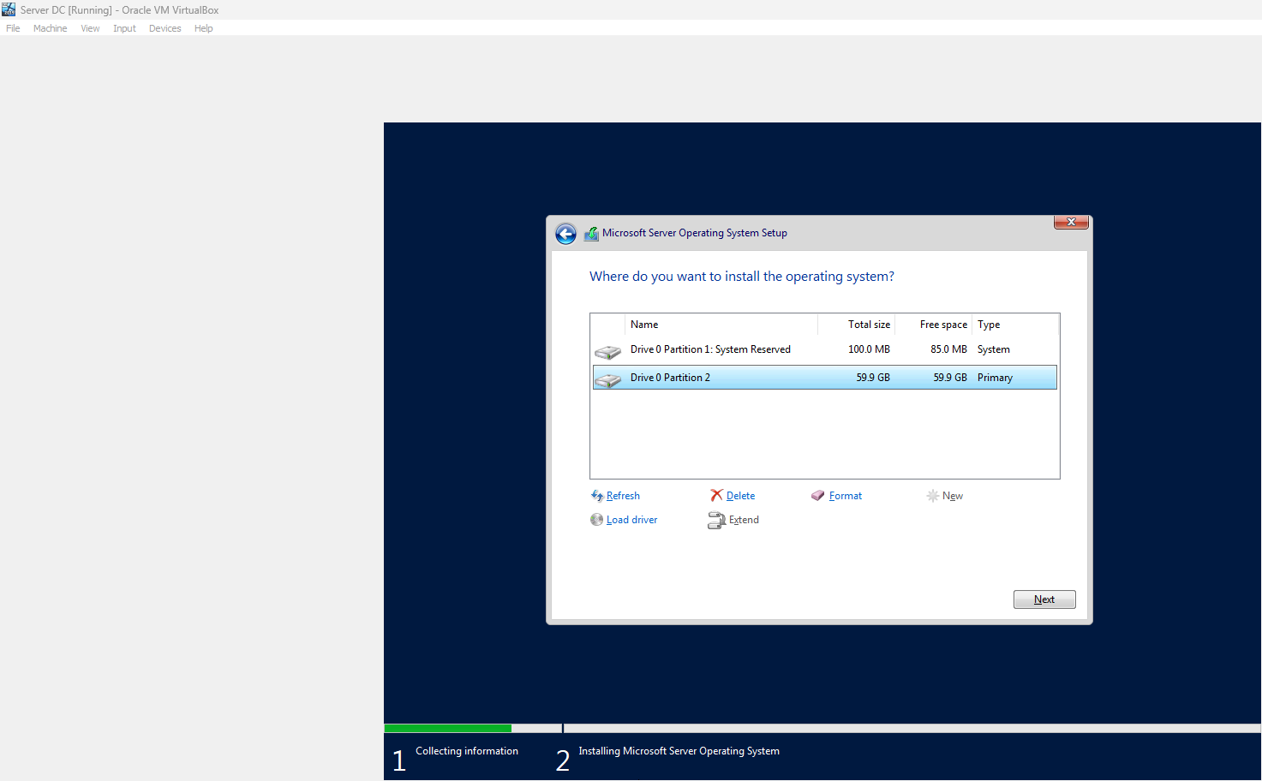
The operating system is then installed onto Drive Partition 2.

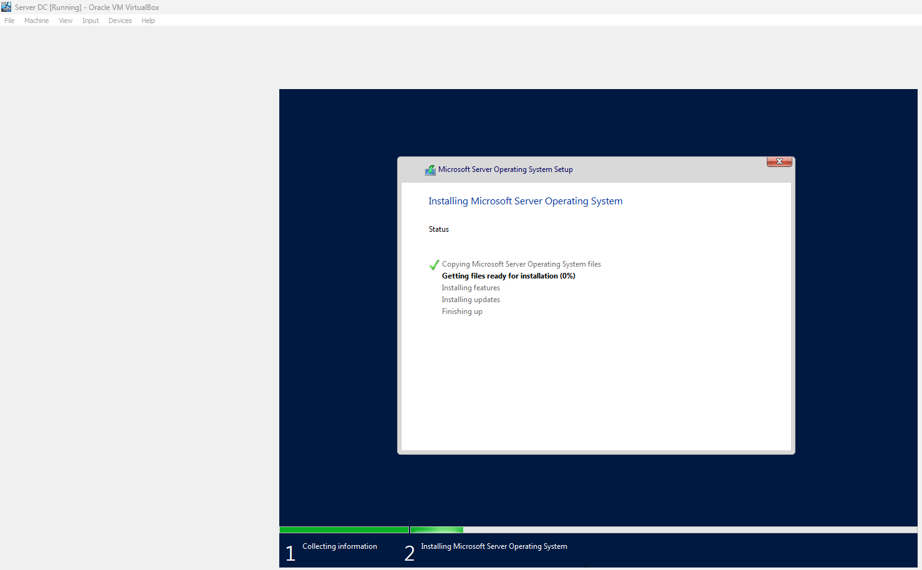
I wait while the Windows Server OS installs.

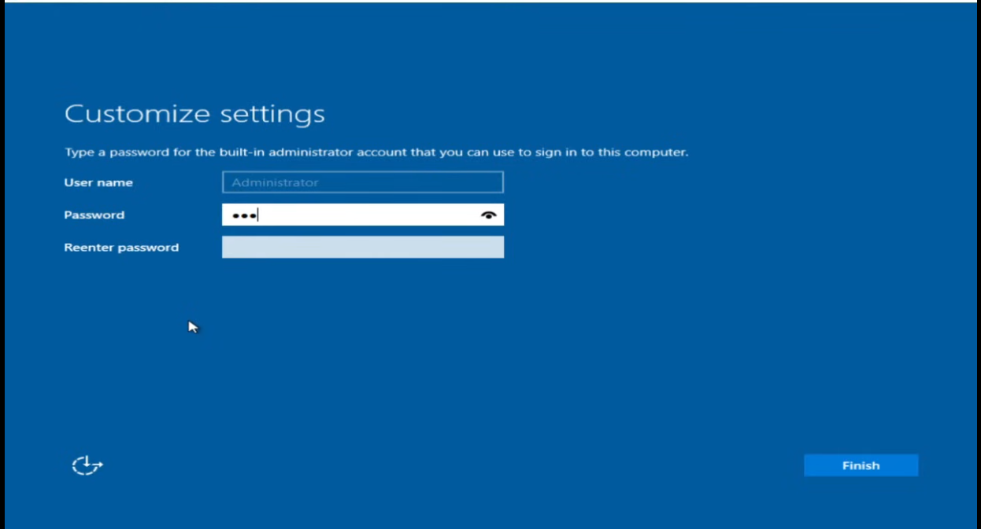
After the installation completes, the server restarts, after which an administrator username and password are created before finalising the setup.

I am then able to log in using the administrator account “Administrator” and the configured password being ”Pa$$w0rd”, confirming that the installation has completed successfully.

Client OS Installation

Next, I install the operating system for the clients on virtual box that I will access this server.

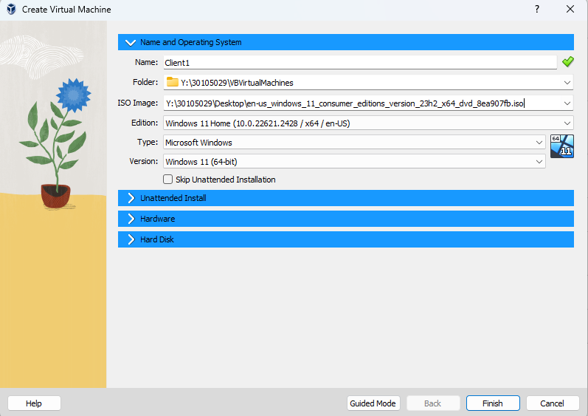
This process closely mirrors the steps used to create the server virtual machine; however, the Windows 11 Consumer Edition ISO is selected instead of the Windows Server 2022 ISO.


The virtual machine is allocated the same hardware resources as the server, consisting of 16 GB of RAM and 4 CPU cores.

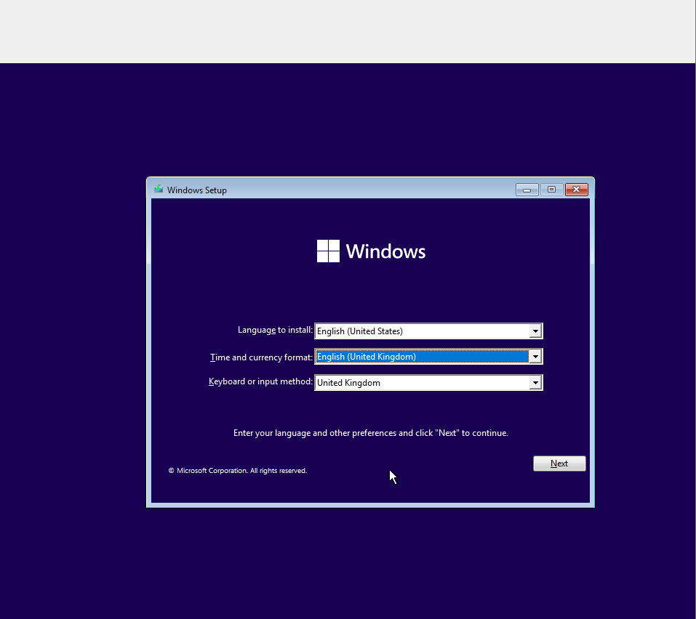
This is the initial screen displayed during the Windows 11 Consumer Edition installation, where English (United Kingdom) is selected before proceeding by clicking Next.
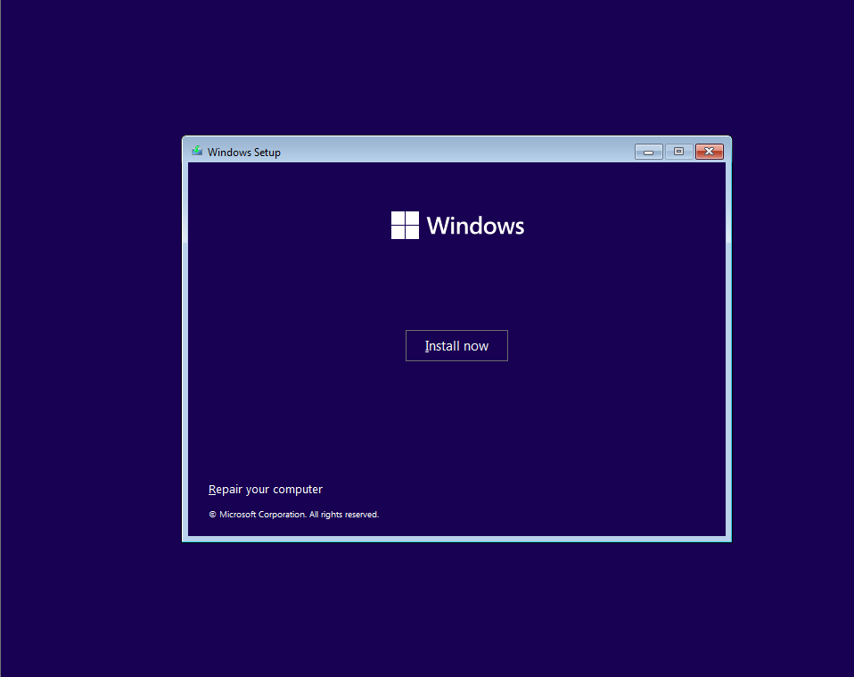
To initiate the operating system installation, the Install Now button is selected.
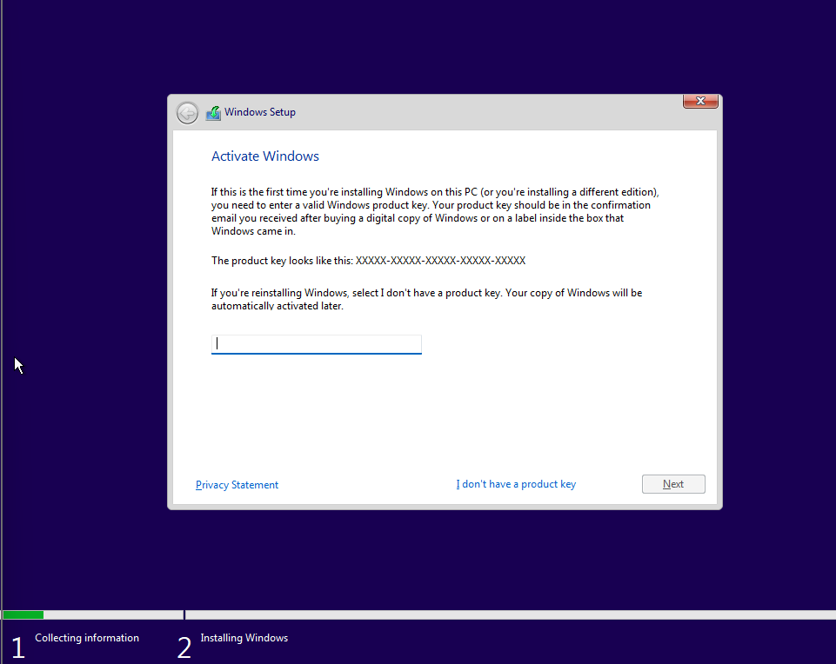
As a product key is not available, the installation continues by selecting the I don’t have a product key option.
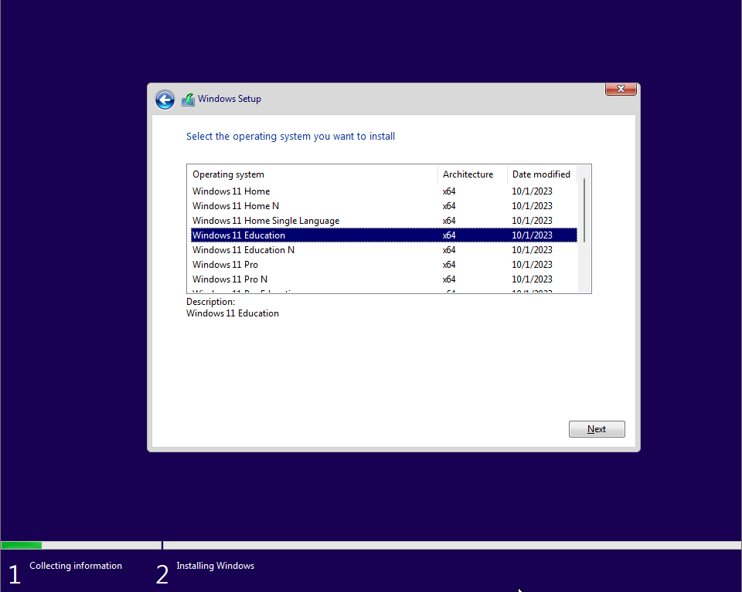
Windows 11 Education is selected for this installation, as the system is being used for a college project, before proceeding by clicking Next.
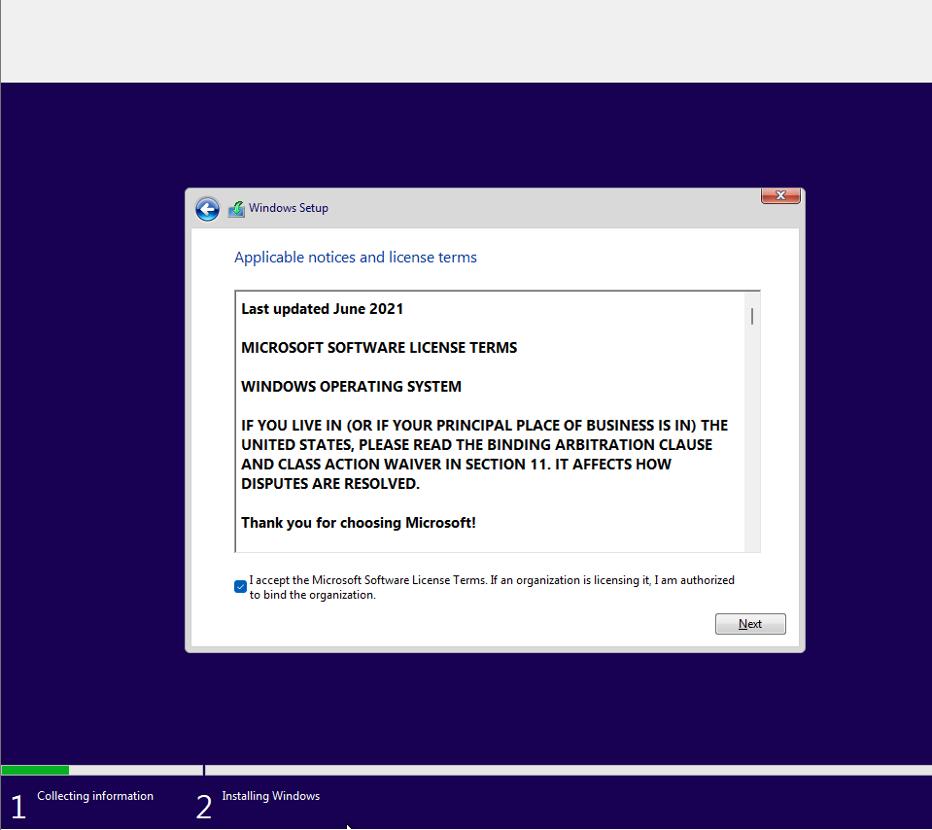
The Microsoft software licence terms are accepted, after which the installation proceeds by selecting Next.
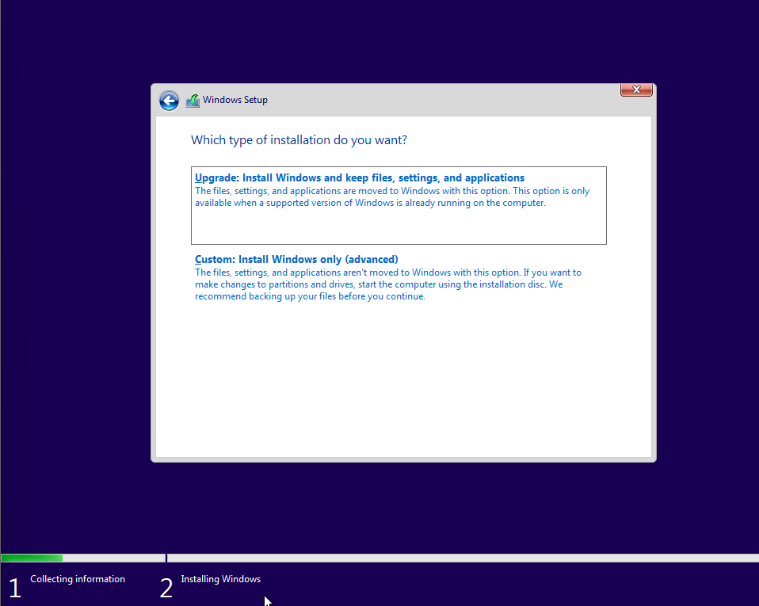
As with the server installation, there is no existing Windows installation present, so the Custom Install option is selected.
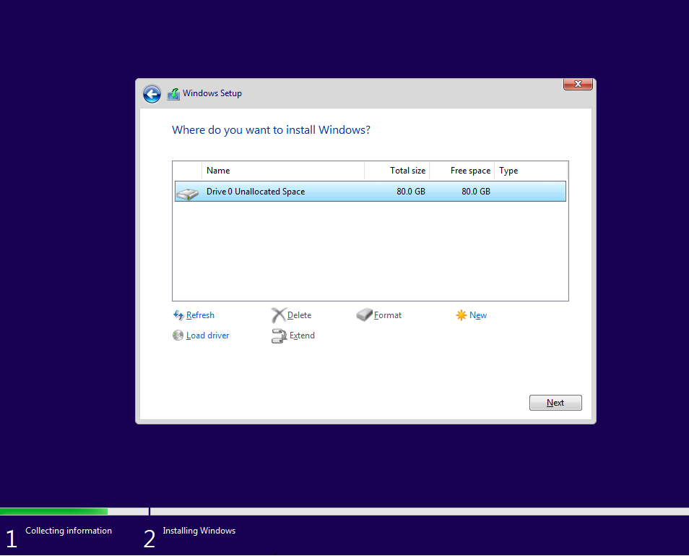

The drive is not partitioned at this stage, instead, the full 80 GB disk is selected before clicking Next.

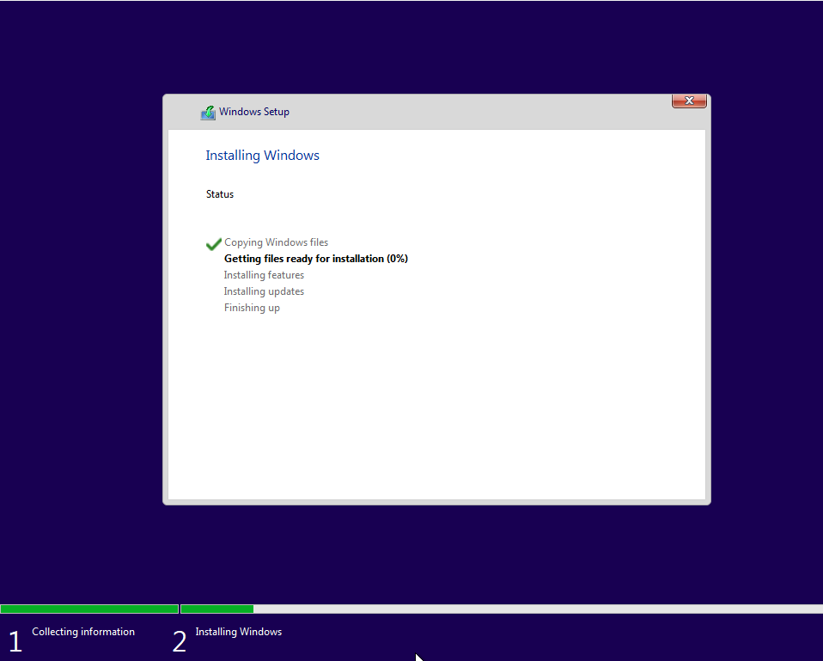
This initiates the operating system installation, and the process is allowed to complete to confirm that the installation has been carried out successfully.

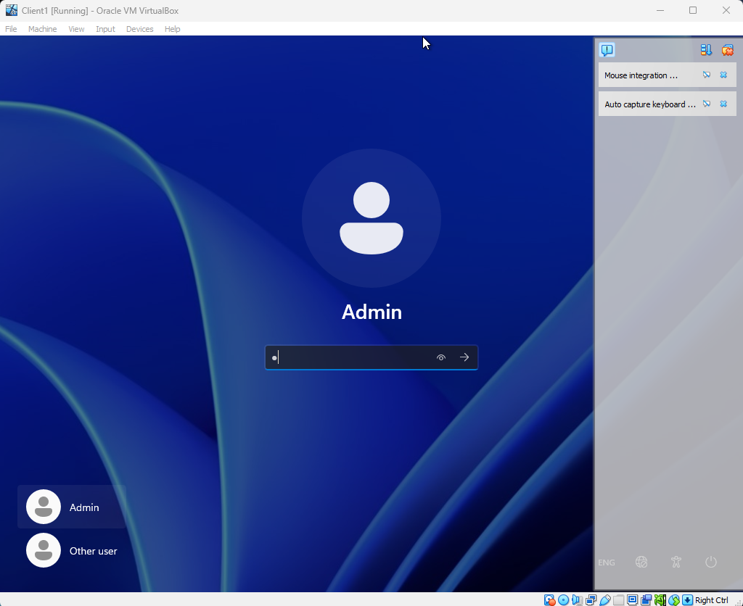
After the virtual machine restarts, I can log in and verify that the installation process has completed successfully.
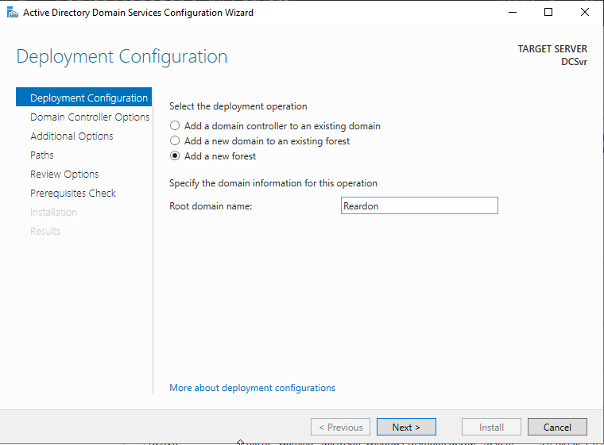
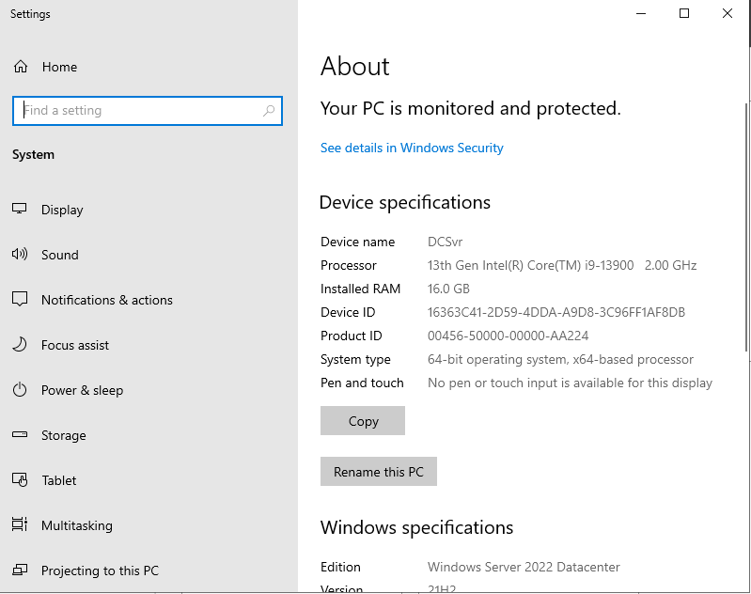
Once both the client and server operating systems are installed, one of the initial configuration steps is to rename the server to a more appropriate identifier, DCsvr.

A new forest is then created, within which a new domain named Reardon is configured, followed by setting a password for the domain controller.
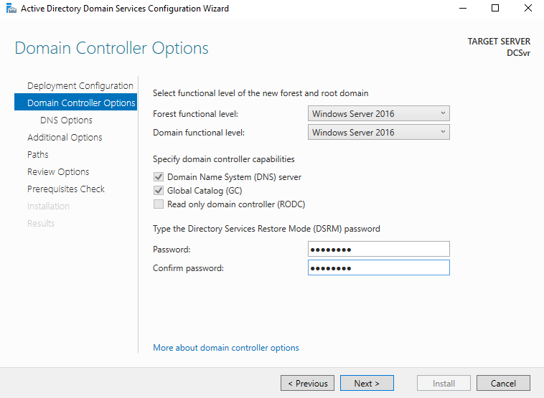

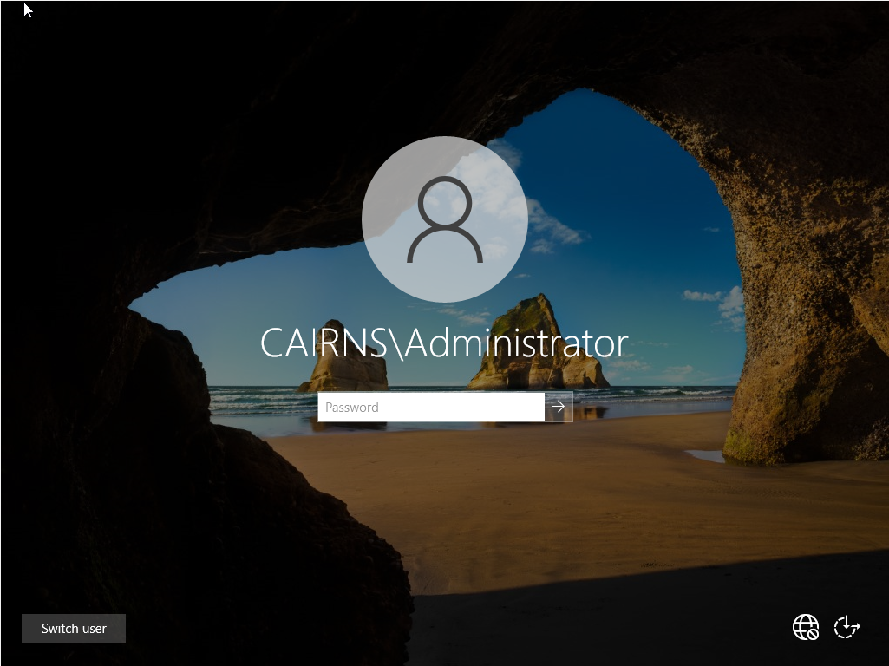

The server virtual machine is then restarted to verify that the domain configuration has been applied successfully, which is confirmed by the CAIRNS\ prefix appearing before the Administrator username.

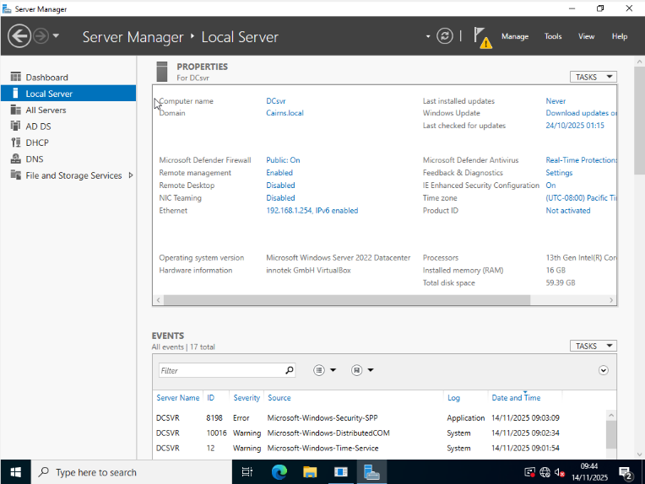
Although the screenshots shown are not my own, I can confirm that the same configuration process was followed, as demonstrated by my Server VM showing a correctly configured domain within Server Manager. My domain is named Cairns.local.

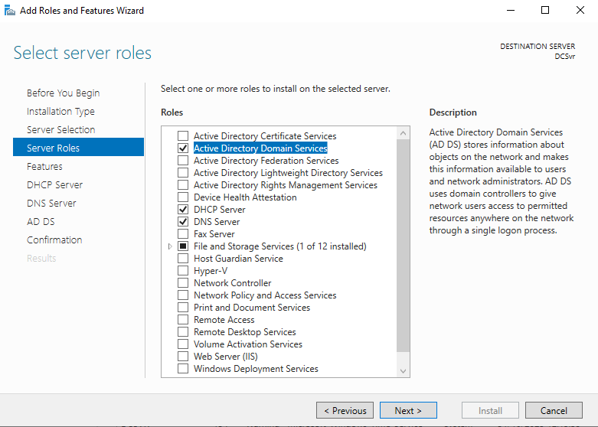

The required server roles are then selected, including Active Directory Domain Services, DHCP Server, and DNS Server, before proceeding by clicking Next.

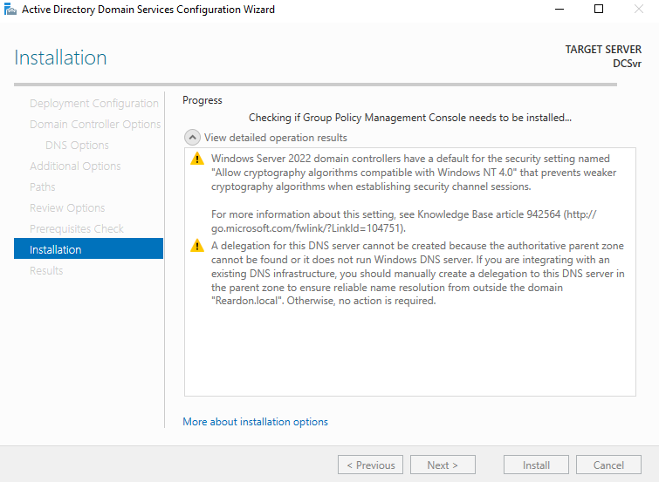

The remaining installation steps are progressed by selecting Next, after which the installation is initiated by clicking Install.

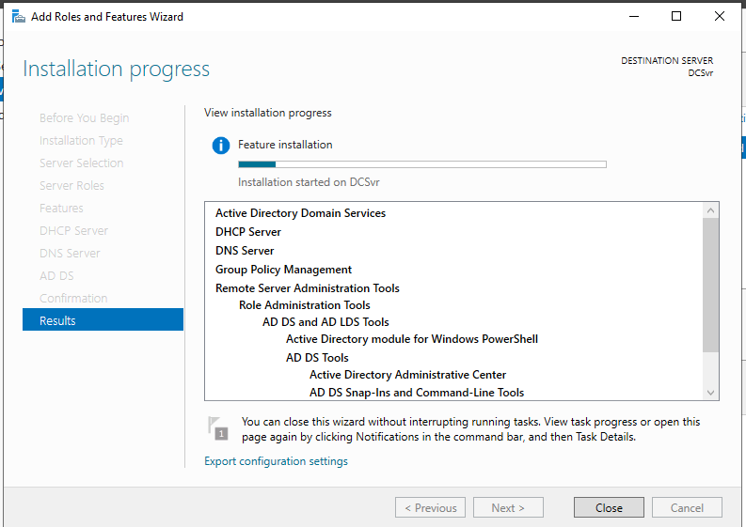
The system is then allowed to complete the installation of the selected server roles.
Assessor’s signature |  | Date

Stage 4 — Configure appropriate network authentication services for domain users. Ensure that password complexity is enforced and password lockout policy is set to remain locked out until unlocked by an administrator.

Screenshots of configuring the Domain’s built in GPO
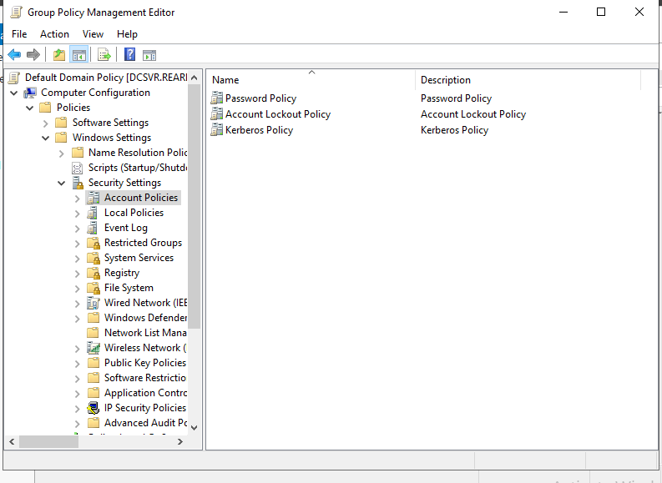
The account policy section is first located within the Group Policy Management Editor.
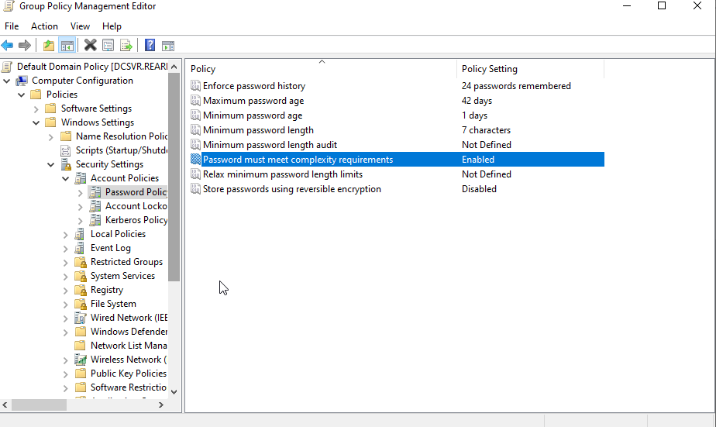

The password complexity policy is enabled to ensure that user passwords comply with defined security standards.

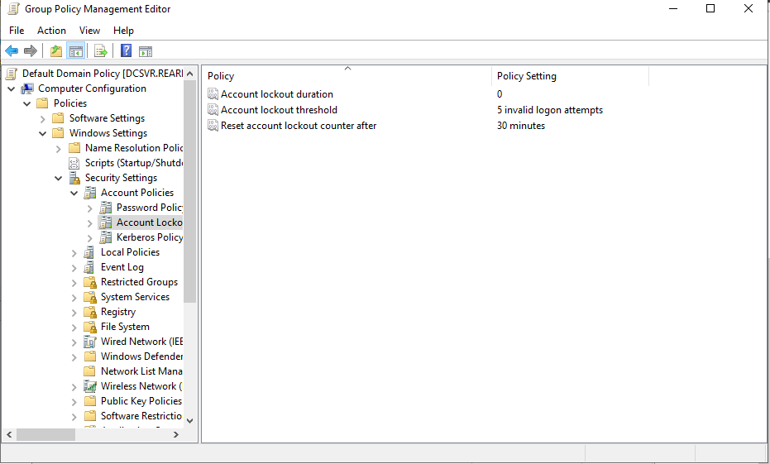
The account lockout policy is configured to lock user accounts after five failed login attempts, with access only restored by an administrator, while the failed-attempt counter resets every 30 minutes.

Assessor’s signature |  | Date

Stage 5 — Using the addressing scheme provided at stage 2, implement
network DHCP services within the LAN. This will require appropriate configuration of your deployed server to provide DHCP services.
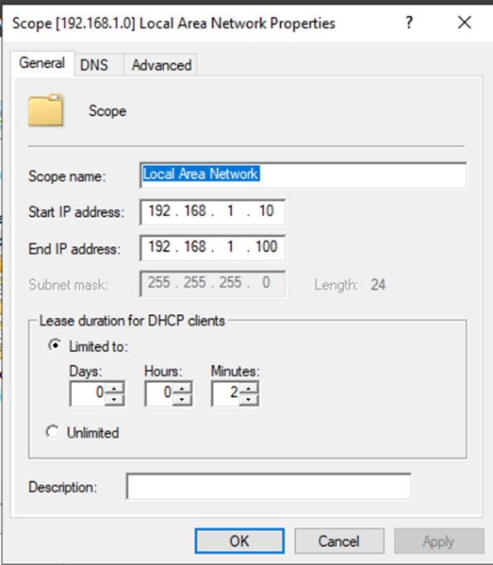
A DHCP scope is created for the local network, covering IP addresses from 192.168.1.10 to 192.168.1.100, allowing the server to automatically assign addresses within this range to connected devices.
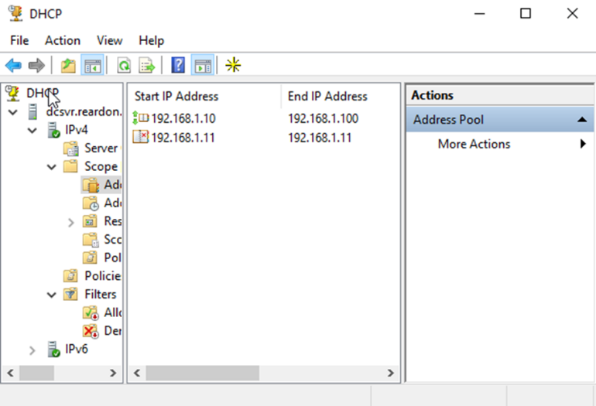
An exclusion is configured for the IP address 192.168.1.11, preventing it from being assigned to any device on the network.
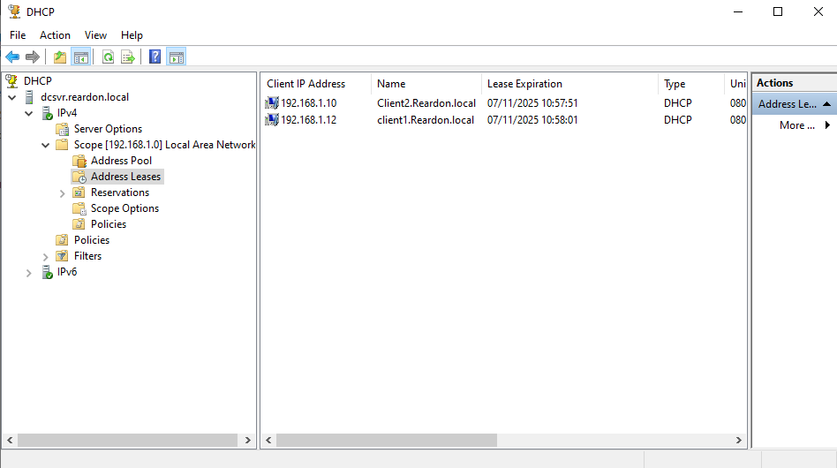
This is confirmed by reviewing the IP addresses assigned to network users, which begin at 192.168.1.10, skip the excluded address 192.168.1.11, and continue at 192.168.1.12.

Assessor’s signature |  | Date

Stage 6 — Harden the endpoint devices/hosts by installing virus checking software.

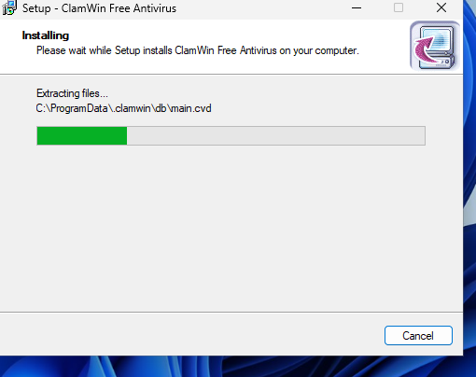
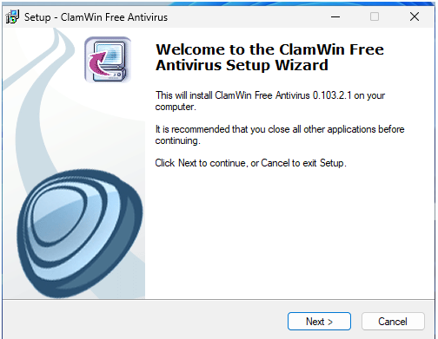

An antivirus application, ClamWin, is installed to provide virus scanning and protection.

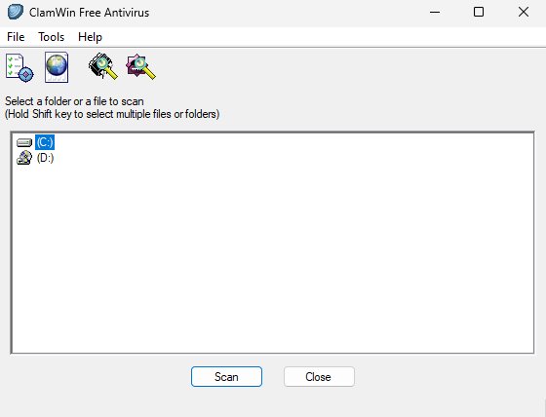
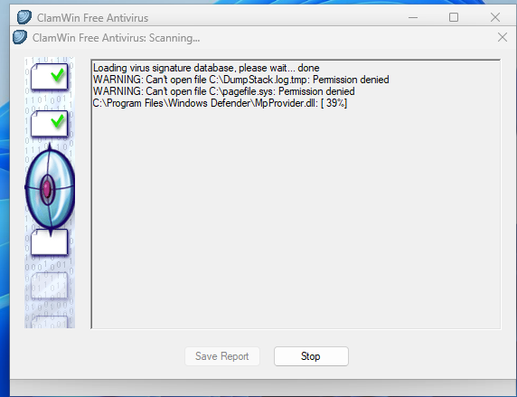

Once the installation is complete, the C: drive on the virtual machine is selected and a full scan is performed.

Assessor’s signature |  | Date

Stage 7 — Configure endpoint devices’ firewalls to allow network hosts to ping each other. Describe the steps taken.

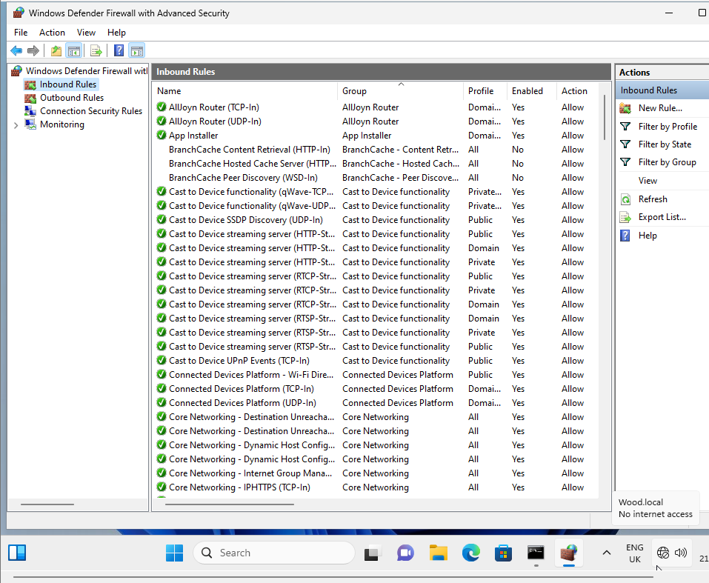

The Windows Defender Advanced Security console is opened, and the File and Printer Sharing rules are located.

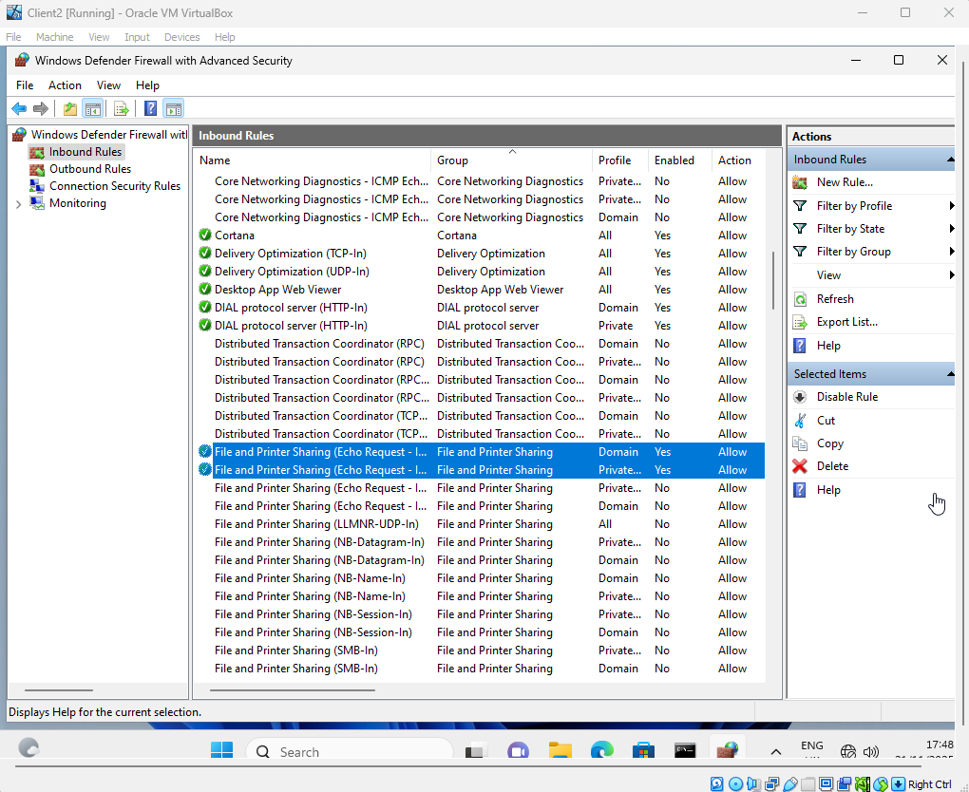

Once located, both rules are selected and enabled.

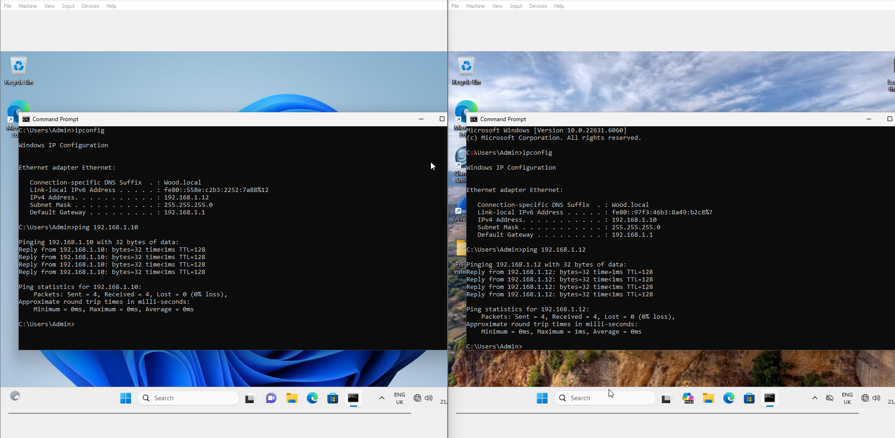
The Command Prompt is then opened, and the ipconfig command is used to identify the IP addresses of the two client machines. Using this information, each client is pinged to confirm that packets are successfully sent and received.
Assessor’s signature |  | Date

Stage 8 — Create a folder on the client in C: drive with the name Backup. On the server, create a backup for System state and schedule it to run daily at 3am. The backup should be saved to the Backup folder you created on the Client.

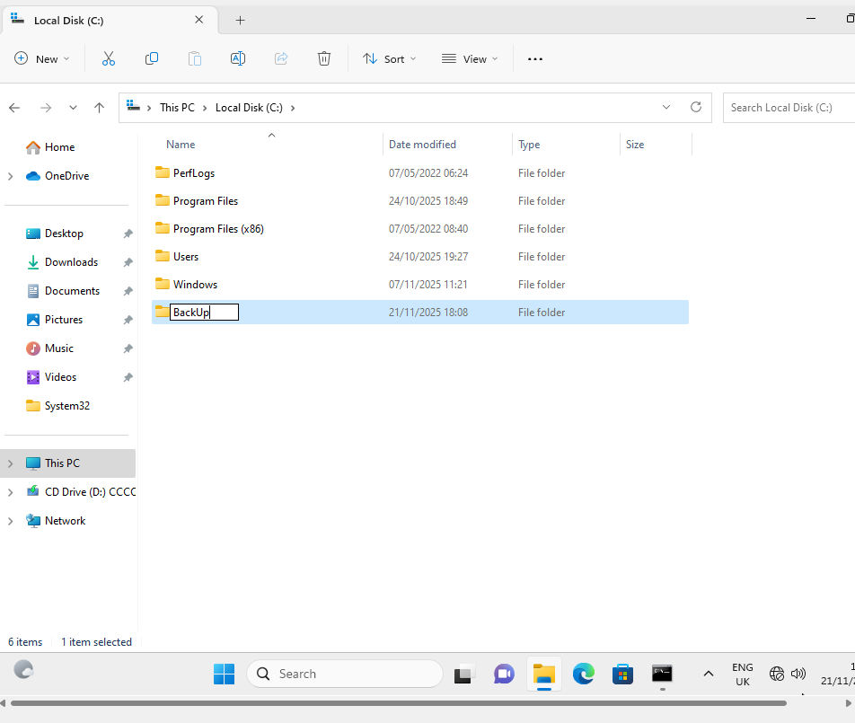
To begin the backup process, a folder named Backup is created on the C: drive of one of the client machines.
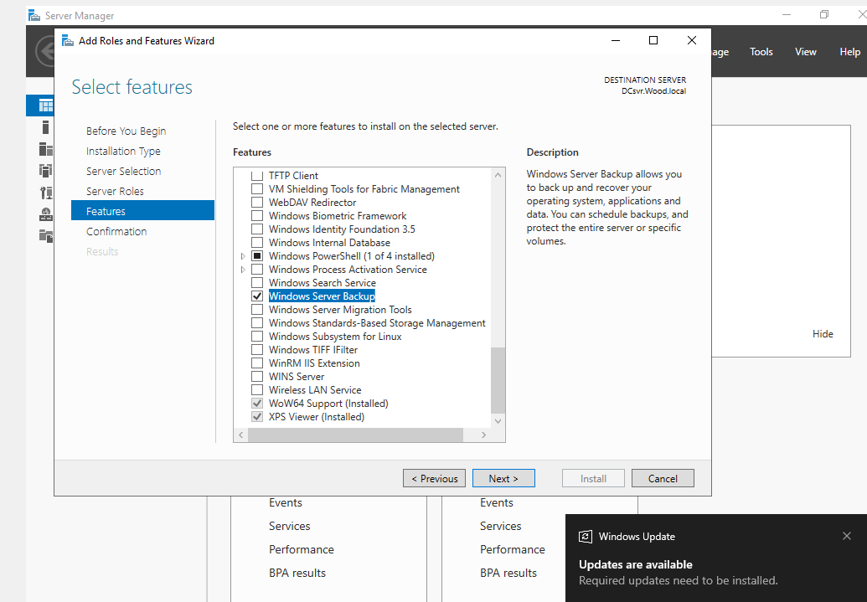
The Windows Server Backup feature is installed on the server virtual machine.

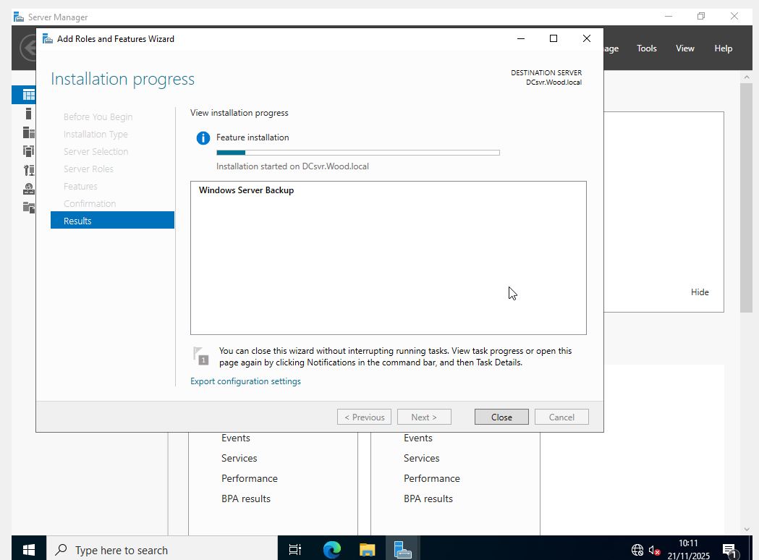
The installation is confirmed by selecting Install, after which the process is allowed to complete.

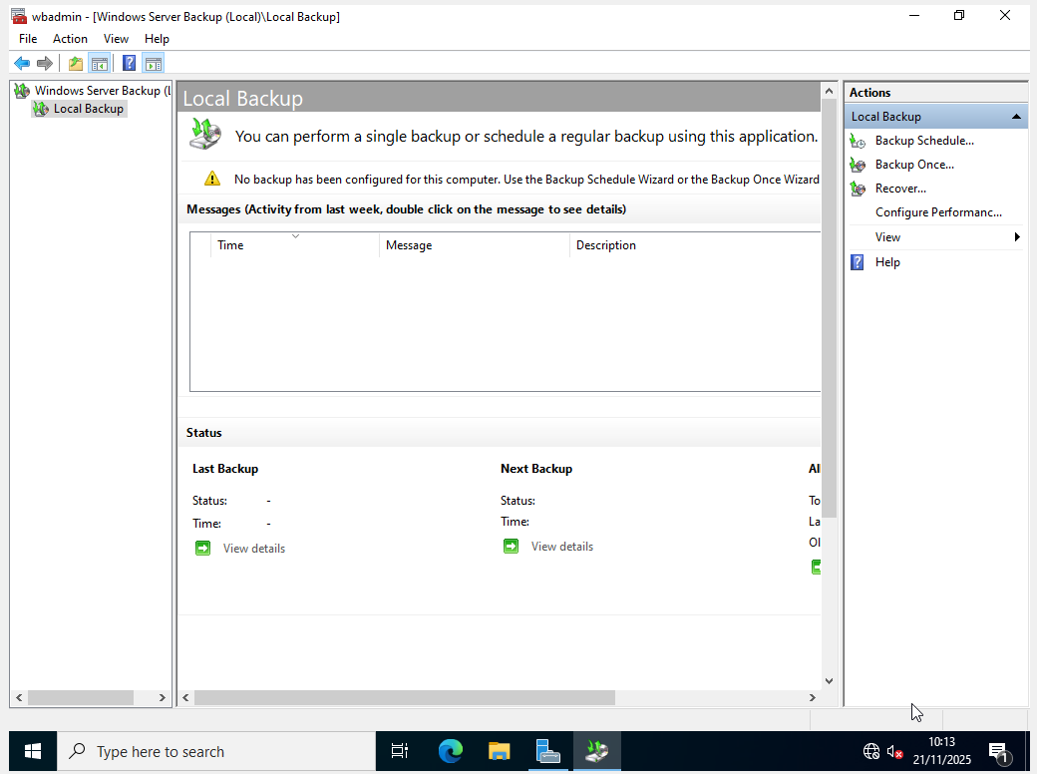
I navigate to the Local Backup.
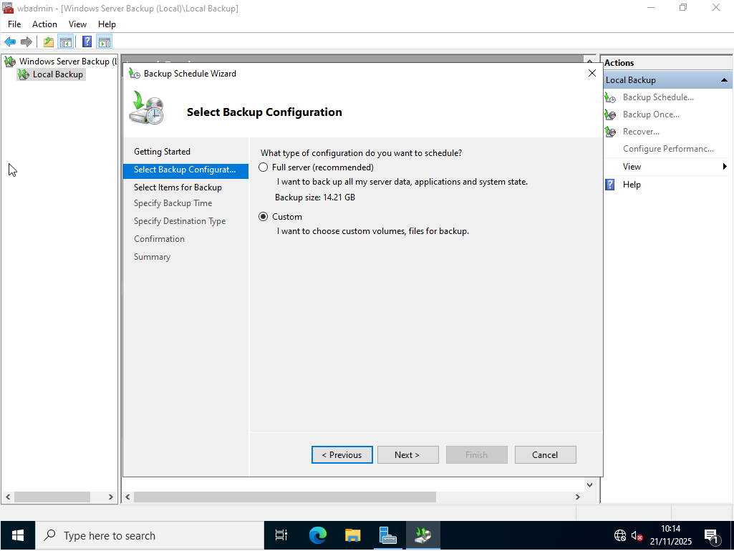
A backup configuration is selected, however, due to time constraints, a custom backup is chosen instead of a full server backup.
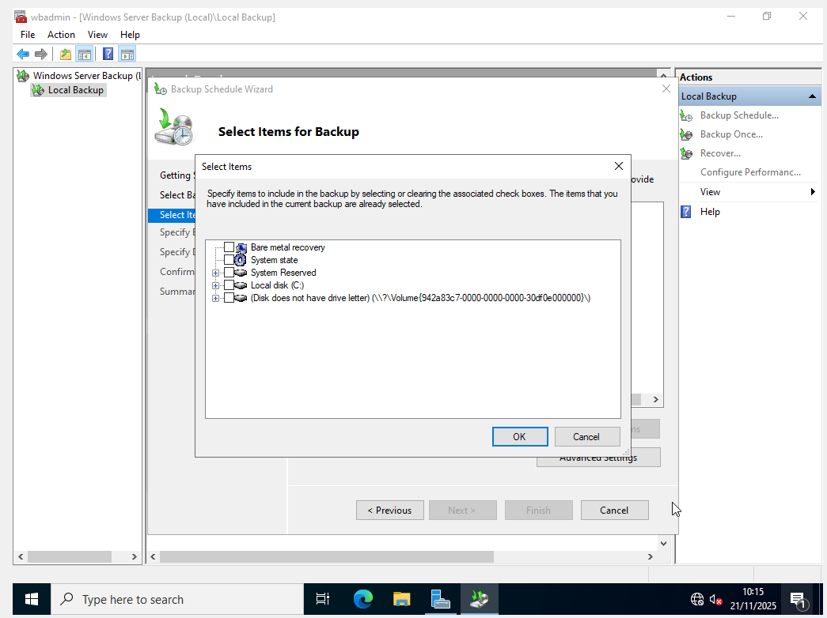
At this stage, the components of the server to be included in the backup can be selected, with System State chosen first.

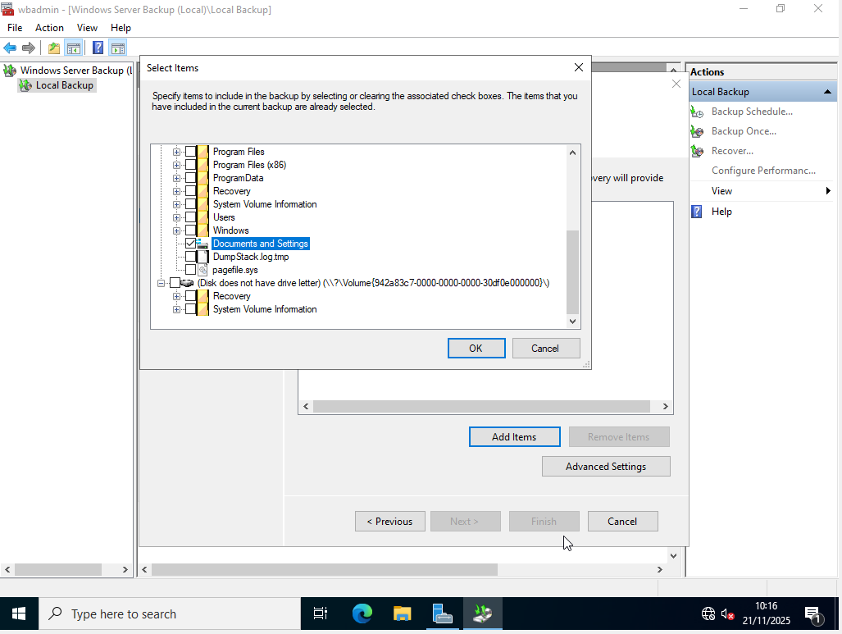
The Documents and Settings option is then selected and confirmed by clicking OK.
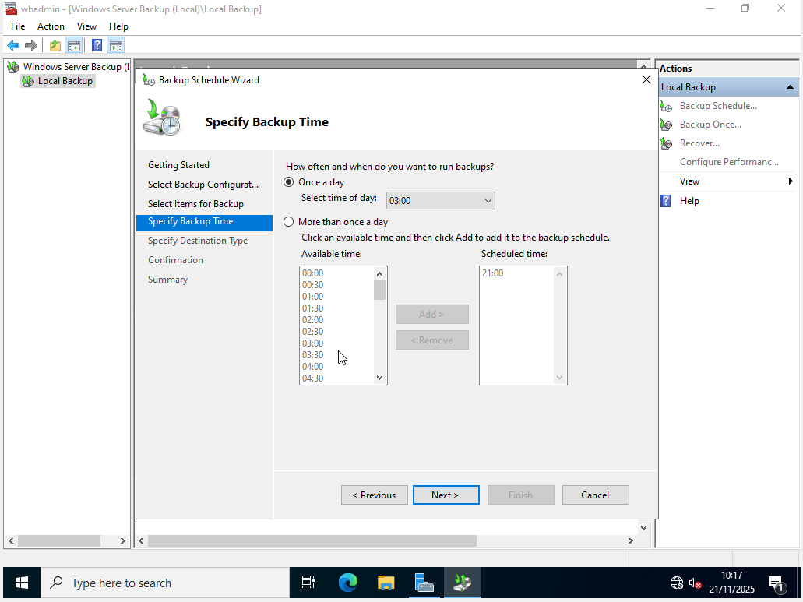
The backup schedule is then configured by setting the time and frequency. In line with the assessment requirements, the backup is set to run daily at 03:00, before selecting Next.
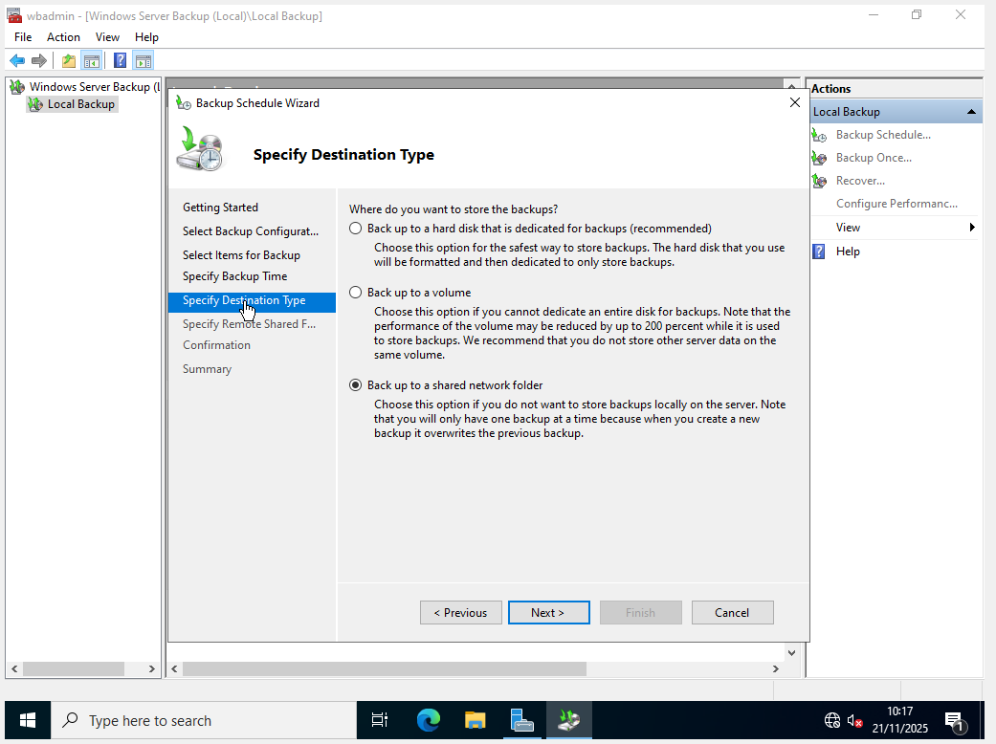
The option to back up to a shared network folder is selected, after which the setup continues by clicking Next.

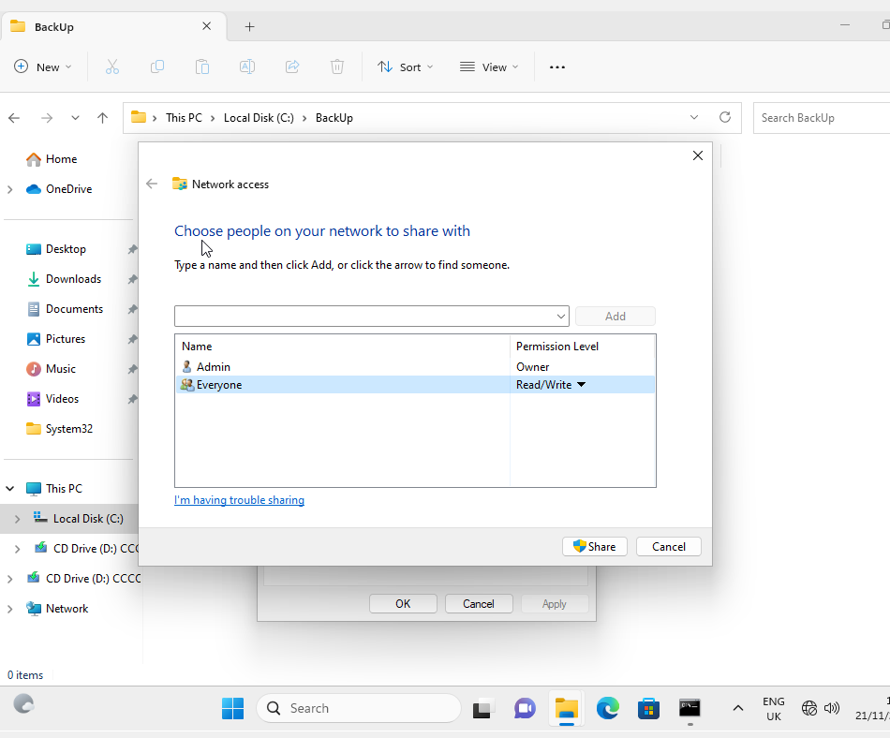
The client machine is then revisited, and the Backup folder is shared on the network with full access granted to all users. While this is not considered best practice, it is acceptable for the purposes of this assessment.
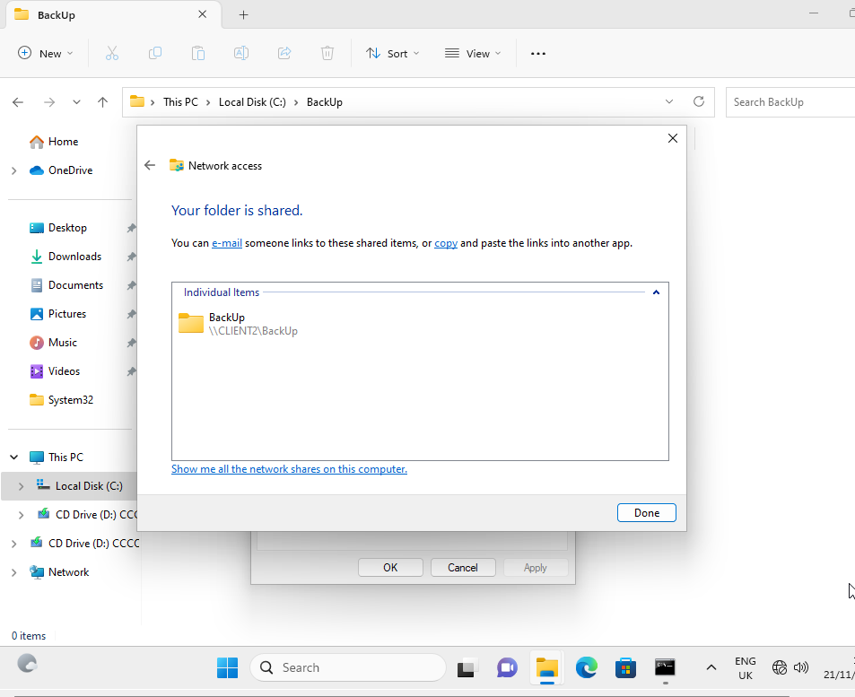
Once the folder is shared, a network path is provided that allows it to be accessed from the server, shown as \\CLIENT2\\BackUp.
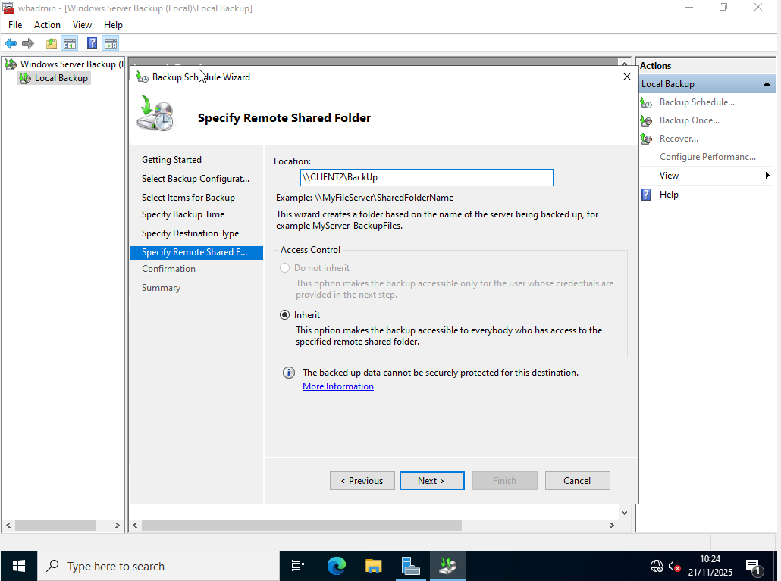
I then return to the server and specify the remote shared folder using the network path \\CLIENT2\\BackUp, before clicking Next to set this as the backup destination.

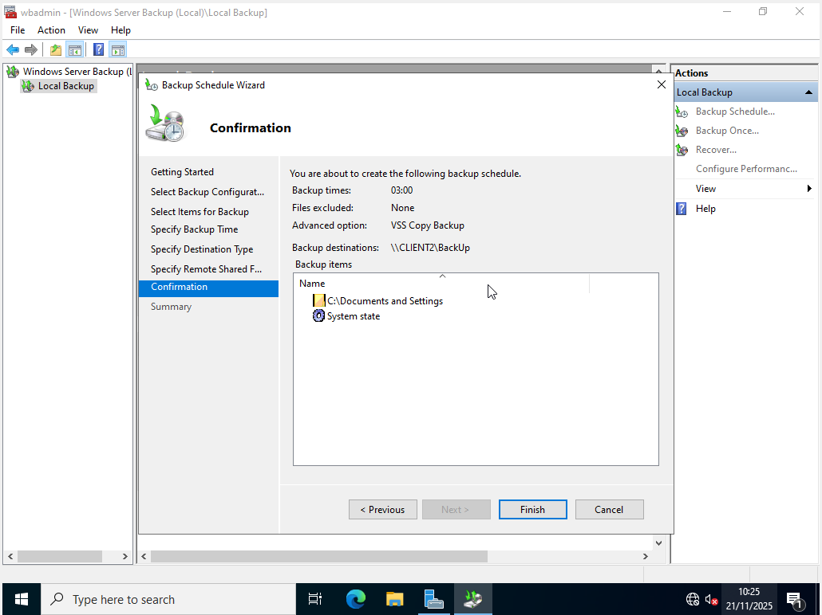
The selected backup components. Documents and Settings and System State are reviewed and confirmed before clicking Finish.

Assessor’s signature |  | Date

Assessment 3

Outcome covered 3 Assessment instructions
Create a secure wireless network
Scenario — You have been tasked with setting up a secure wireless network for your given scenario. This should be designed in such a way that it can be integrated into the network design implemented in Outcome 2.

Stage 1 — Devise a list of equipment that will be required to allow wireless technology to be implemented within your given scenario.
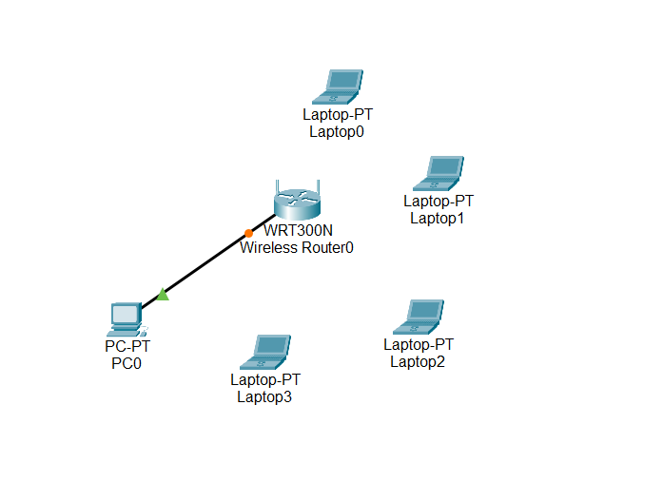
The following equipment is required to implement the wireless network:
- A wireless router (WRT300N).
- A desktop PC connected via a copper Ethernet cable.
- Three laptops configured to connect wirelessly.

Assessor’s signature |  | Date

Stage 2 — Obtain and setup the wireless equipment, describe/log/picture log/vlog the steps to achieve this build.
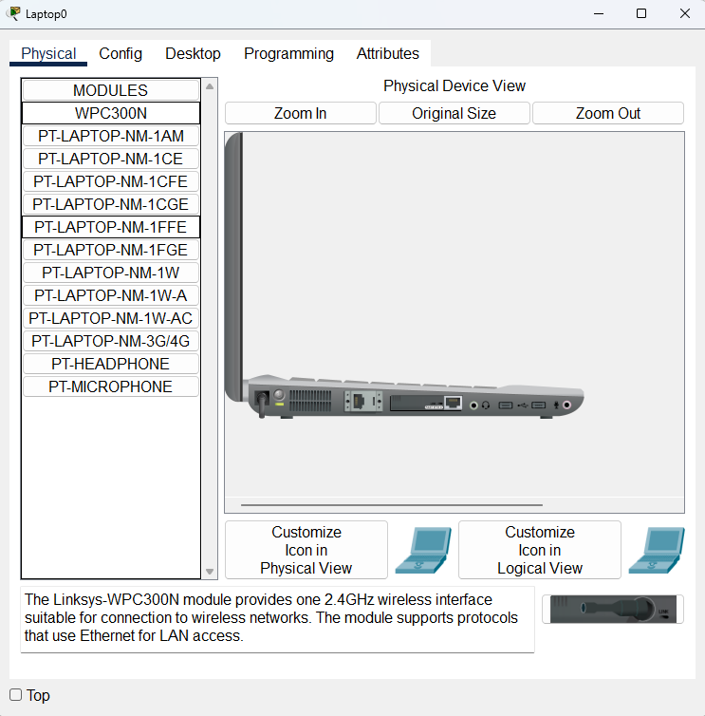

Each laptop is powered down individually, the Ethernet adapter is replaced with a WPC300N wireless adapter, and the laptops are then powered back on to enable wireless connectivity.

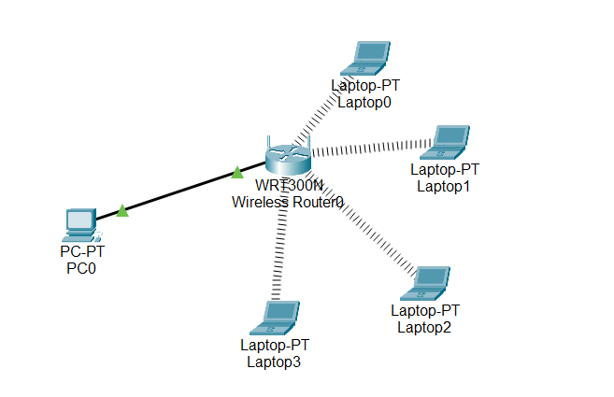

Once all laptops are powered back on, they automatically connect to the wireless router, as indicated by the wavy connection lines shown between the laptops and the router.

Assessor’s signature |  | Date

Stage 3 — Devise and implement a suitable authentication and encryption scheme to allow users to use the wireless network.

Changing and hiding wireless SSID

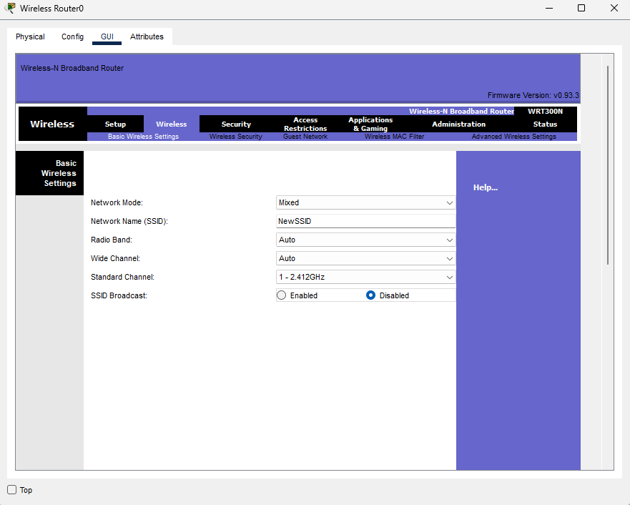
I first access the router’s graphical user interface and navigate to the Basic Wireless Settings, where the SSID is changed from the default value to NewSSID. SSID broadcast is also disabled to conceal the network.
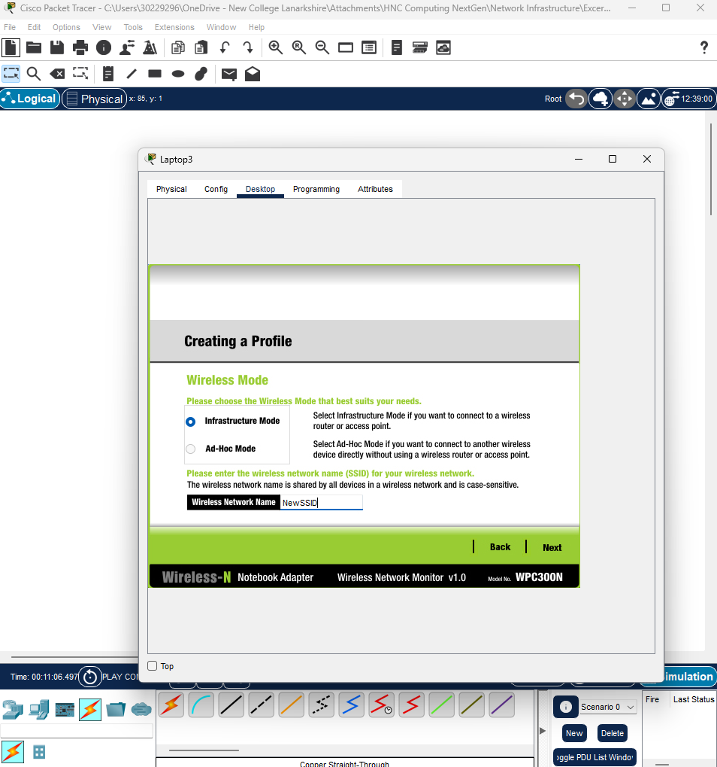
The laptop’s wireless configuration is then accessed, and a new wireless profile named NewSSID matching the router’s SSID is created before clicking Next.

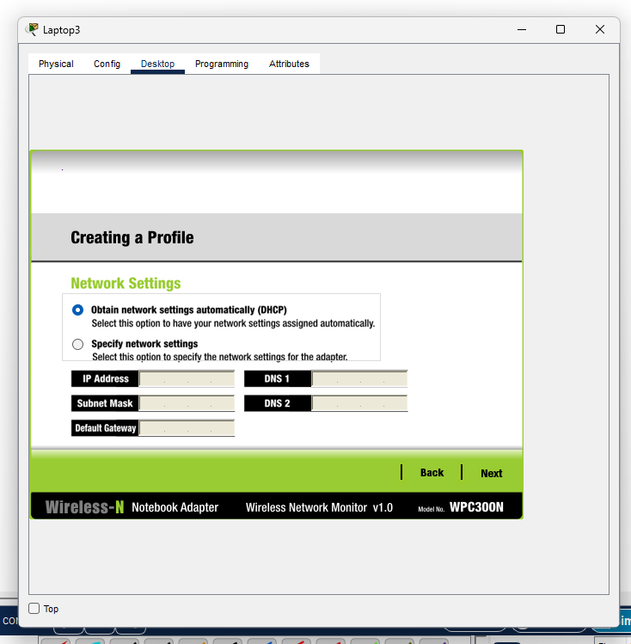
The device is configured to obtain network settings automatically, as DHCP has already been enabled on the router.

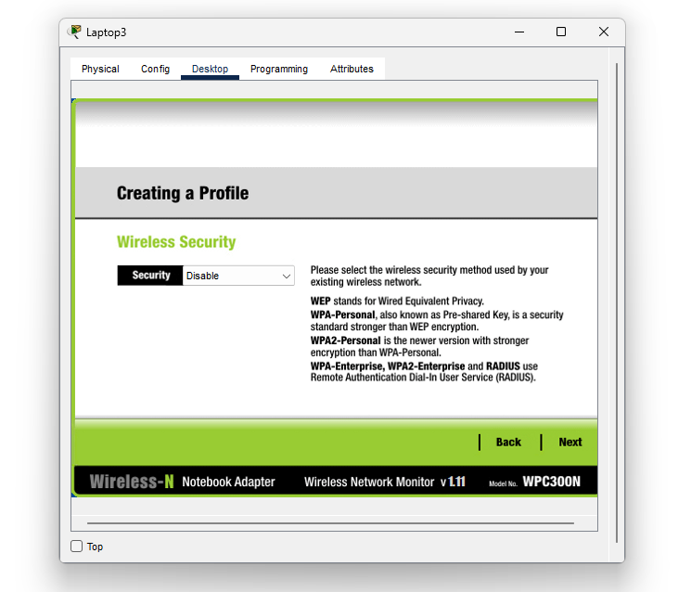
Wireless security could be configured at this stage; however, this is completed in a separate step later in the process.
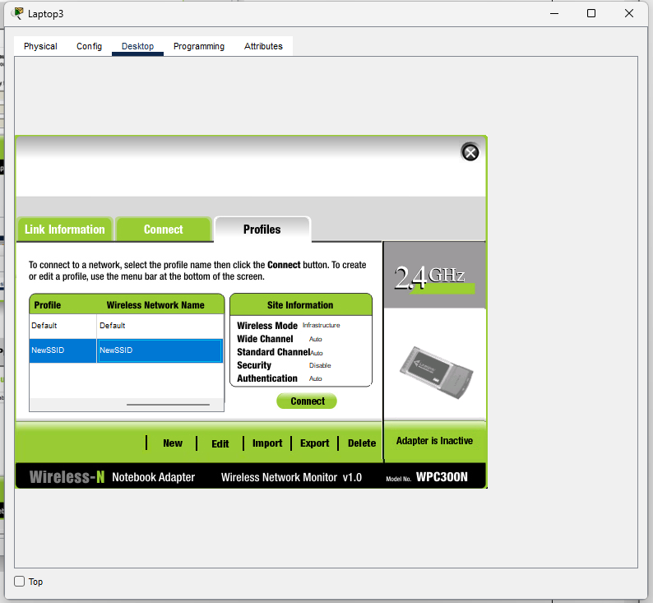
The newly created wireless profile is selected and the device is connected, after which the laptop automatically establishes a connection with the router. This process is repeated for each laptop.
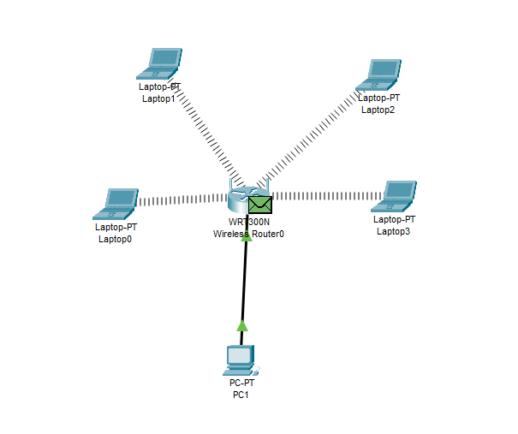
After completing these steps on each laptop, successful configuration is visually confirmed by all devices reconnecting to the wireless router.
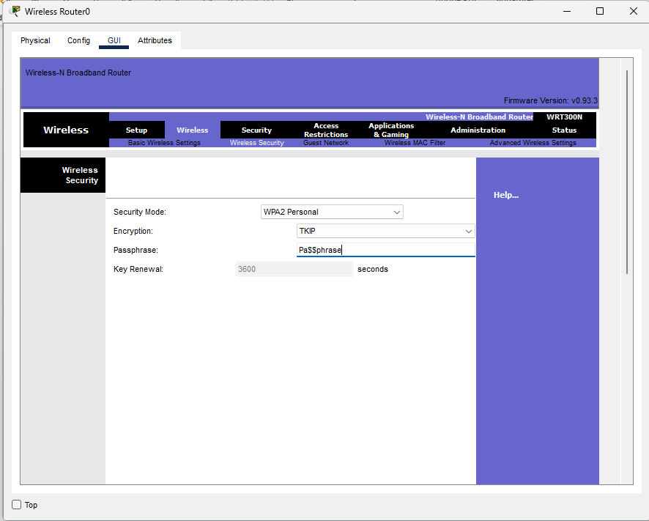
Adding Encryption to the Network

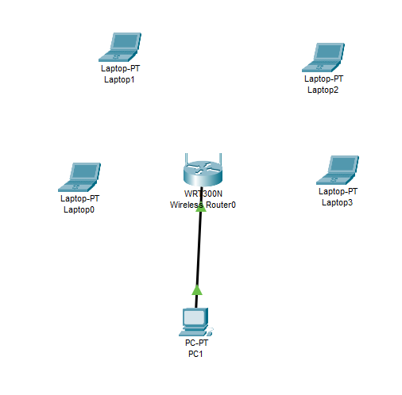

The router’s graphical user interface is accessed, and the Wireless Security settings are opened. The security mode is changed to WPA2-Personal, which is the most current option available in Packet Tracer. TKIP encryption is selected and a passphrase of “Pa$$phrase” is configured.

Applying these settings temporarily disconnects all laptops until WPA2 is configured on each device.
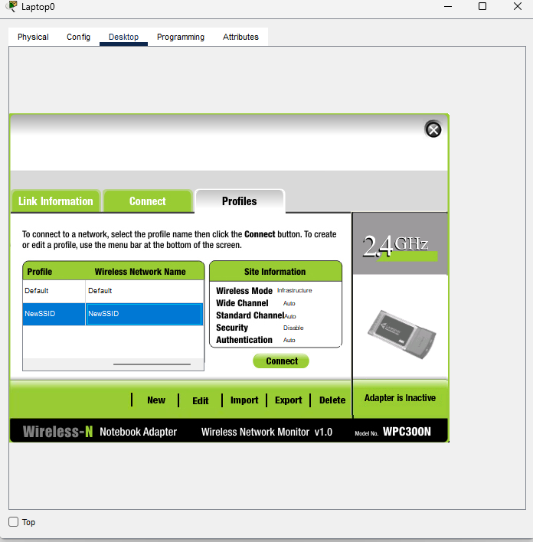
On the laptop, the wireless configuration page is accessed from the desktop, and a new wireless profile is created by selecting New.
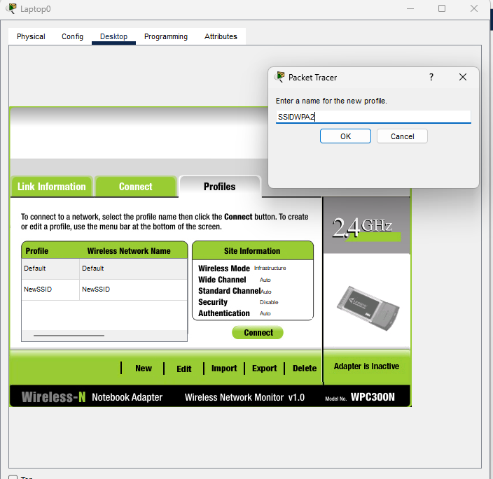
An appropriate name, SSIDWPA2, is assigned to the wireless profile and confirmed by clicking OK.
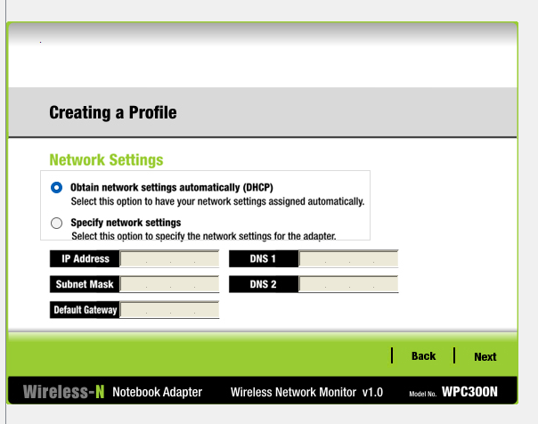
As in the previous configuration stage where the SSID was modified and hidden, DHCP is selected to automatically obtain network settings, as it has already been configured on the router, before clicking Next.

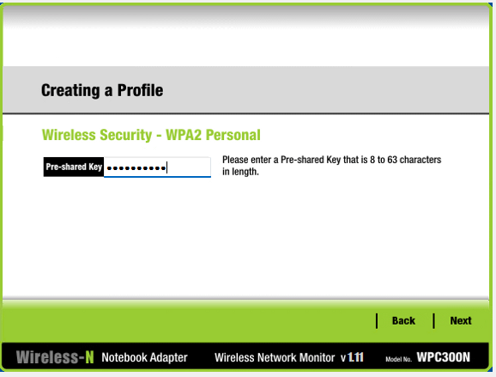
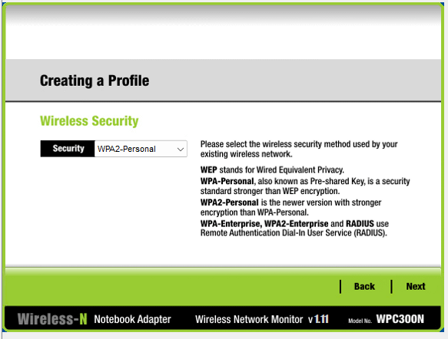
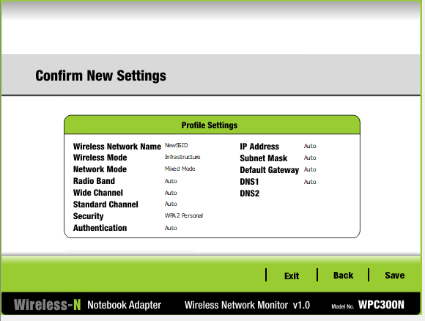
The configured settings are reviewed for accuracy and saved.
The previously configured passphrase, “Pa$$phrase”, is entered and the setup continues by clicking Next.
The WPA2-Personal security option is selected to match the configuration applied on the router.
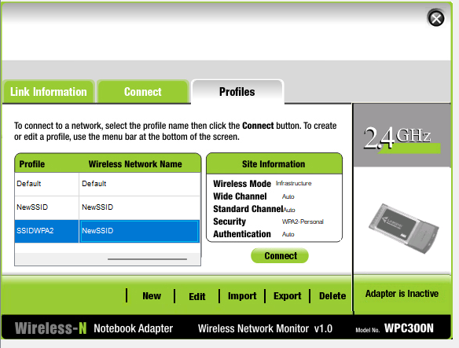
The connection is then established using the newly created wireless profile.
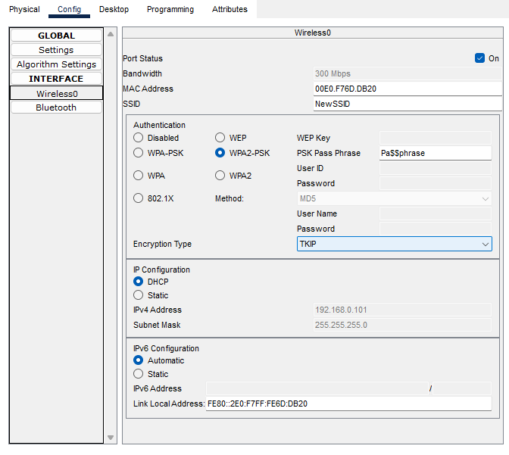
The encryption type in the Packet Tracer wireless configuration is changed to TKIP.
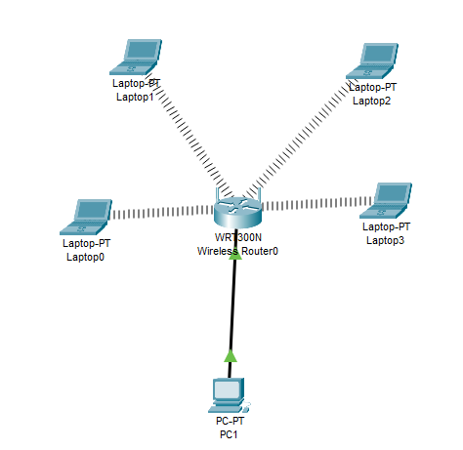
After completing these steps on each laptop, visual confirmation shows that all devices are successfully connected to the wireless network.
Assessor’s signature |  | Date

Stage 4 — Implement wireless MAC address filtering to further secure the wireless network. Describe the steps taken to do this.
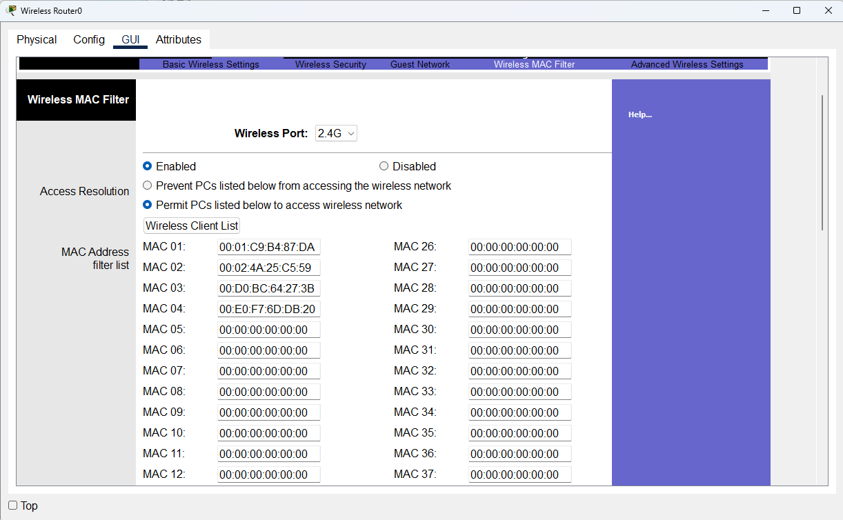
To configure MAC address filtering, the option to permit only listed PCs is selected, and the MAC addresses of authorised client devices are entered. This ensures that only approved devices can access the network.
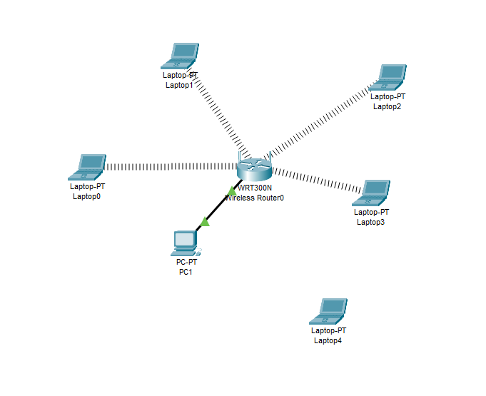
The effectiveness of MAC address filtering is verified by adding a new laptop with a wireless adapter whose MAC address is not included in the permitted list. The device is unable to connect to the wireless router, confirming that the filtering is functioning correctly.
Assessor’s signature |  | Date

Assessment 4

Outcome covered 4 Assessment instructions
Maintain a network Infrastructure.
Scenario — You have been asked to provide a detailed document that includes all design, implantation and testing evidence.

Stage 1 — Based upon the design and implementation sections devise a robust testing strategy that can be implemented prior to the system being used in a production environment. Please Insert a copy of your test plan here.
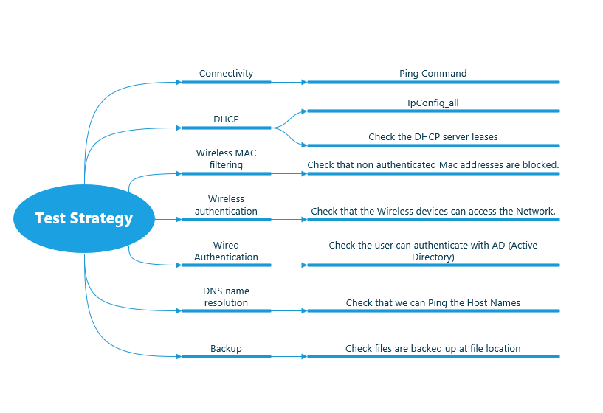
This section outlines the testing plan used to verify each component of the implemented network.

Assessor’s signature |  | Date

Stage 2 — Implement your testing strategy and provide the results below. (Completed test log including relevant screenshots as evidence)
Connectivity
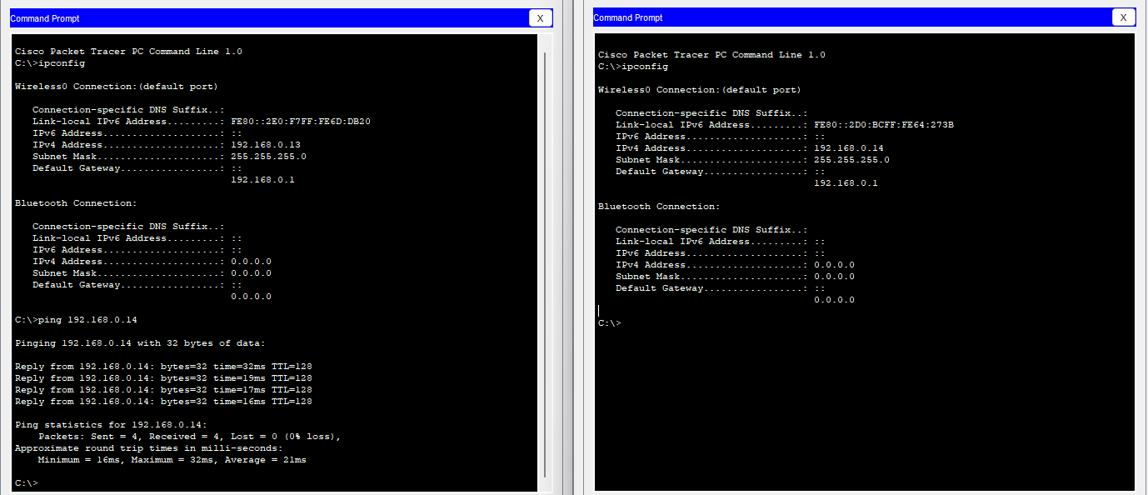
In accordance with the test plan, server and client connectivity was verified using ping commands between devices, ensuring that all packets were transmitted and received successfully with no packet loss.

DHCP
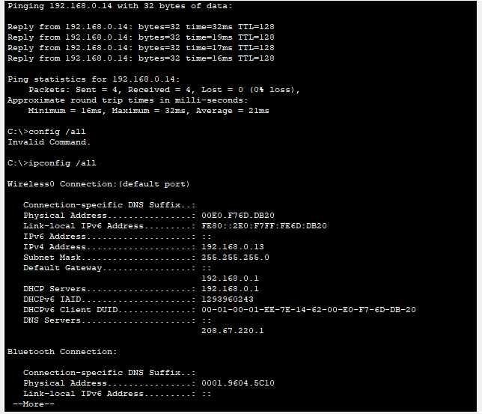

The ipconfig /all command is used on a client machine to confirm that DHCP is correctly assigning IP addresses within the configured range.

Wireless MAC Filtering

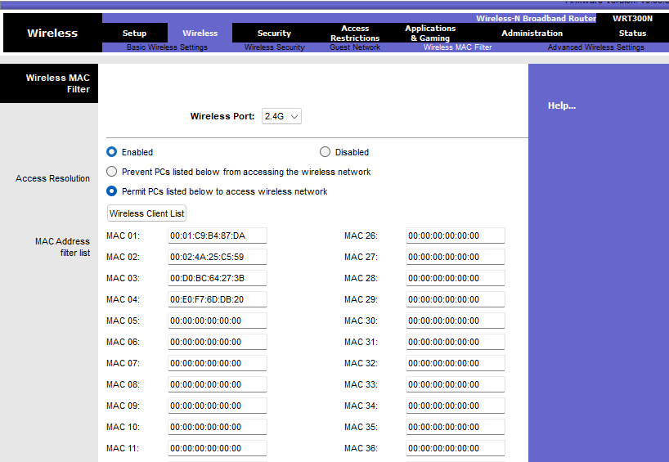
The MAC address filter list displays the authorised MAC addresses permitted to access the network.
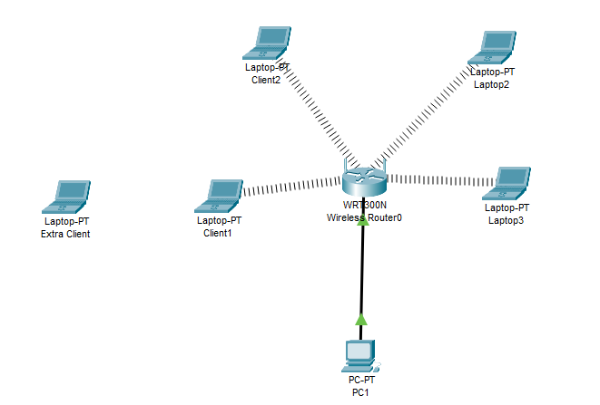
MAC address filtering is confirmed to be functioning correctly by attempting to connect a new client whose MAC address is not listed, resulting in the device being unable to access the network.

Wireless Authentication
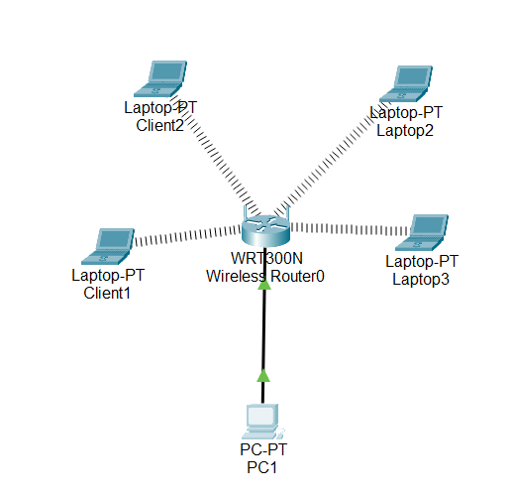
Wireless connectivity is initially verified by visually confirming the presence of wireless connection indicators.
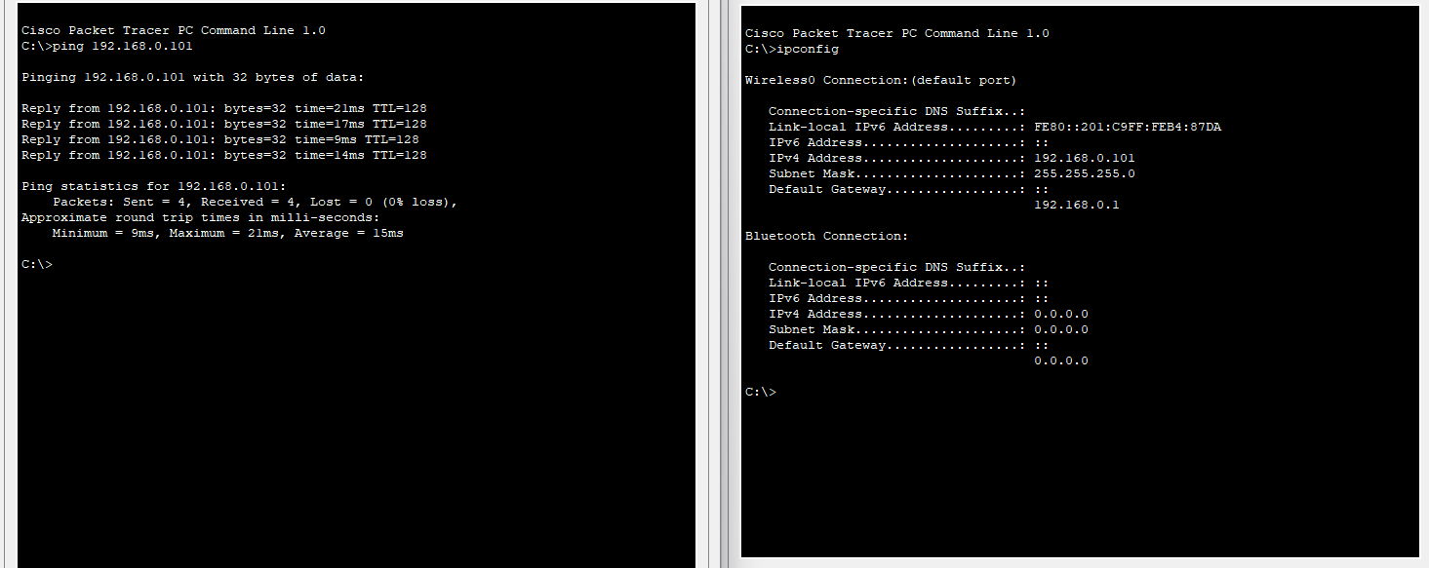

Connectivity is further confirmed by pinging one wireless device from another, with all four packets successfully sent and received, demonstrating full network access.

Wired Authentication
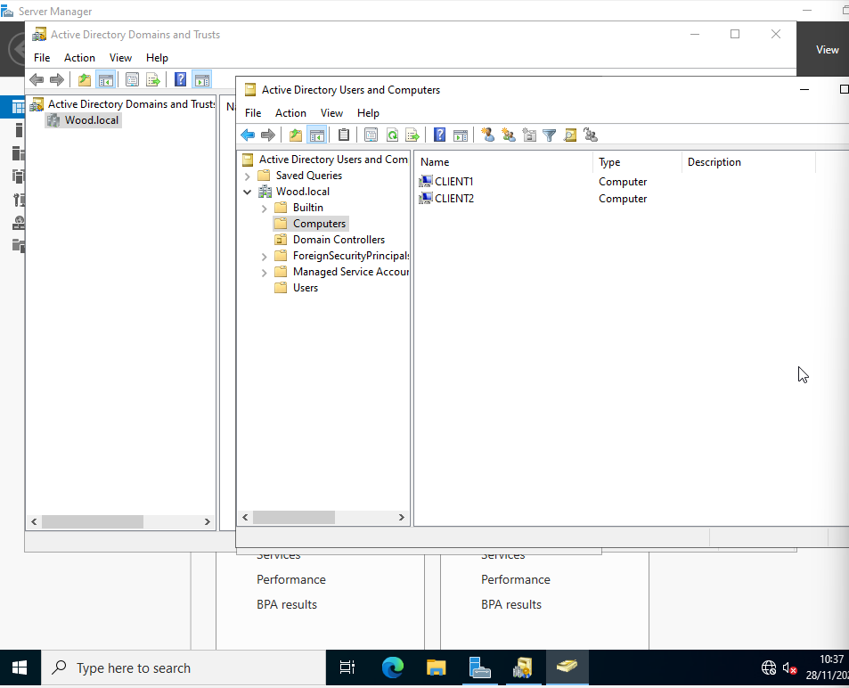

Active Directory functionality is first verified by accessing Active Directory Domains and Trusts on the server, where the two configured client machines are visible within the domain.

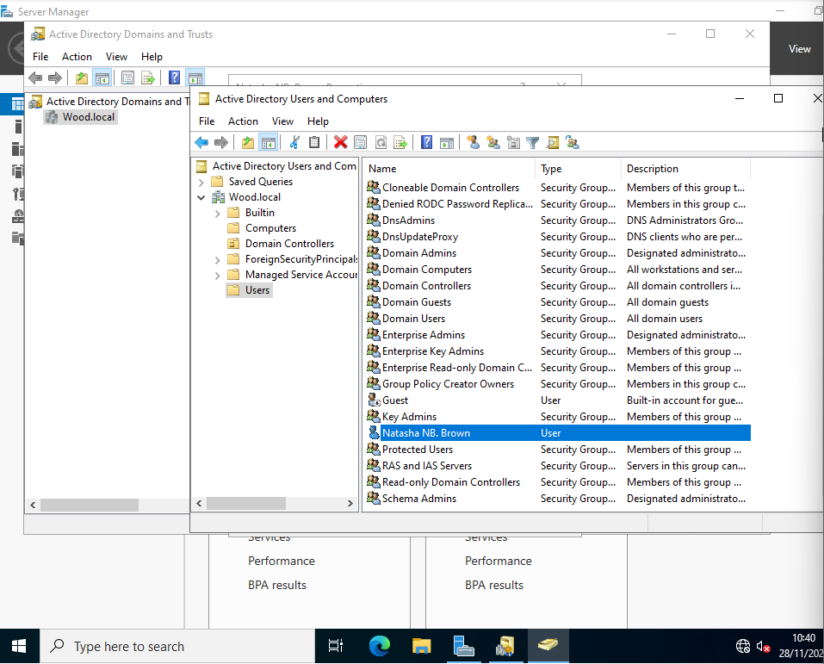

The user accounts on the server are then reviewed, using the highlighted Natasha NB Brown account as an example.

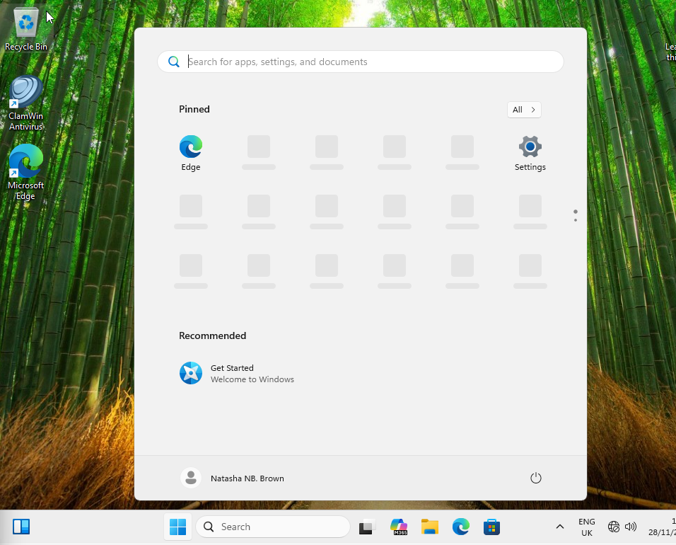
I log in to one of the client machines using the Natasha NB Brown domain credentials, demonstrating that domain users can authenticate and access the network.

DNS Name Resolution
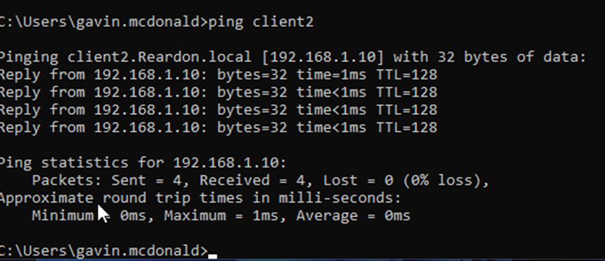

DNS name resolution is verified by pinging a client device using its hostname rather than its IP address.

Backup
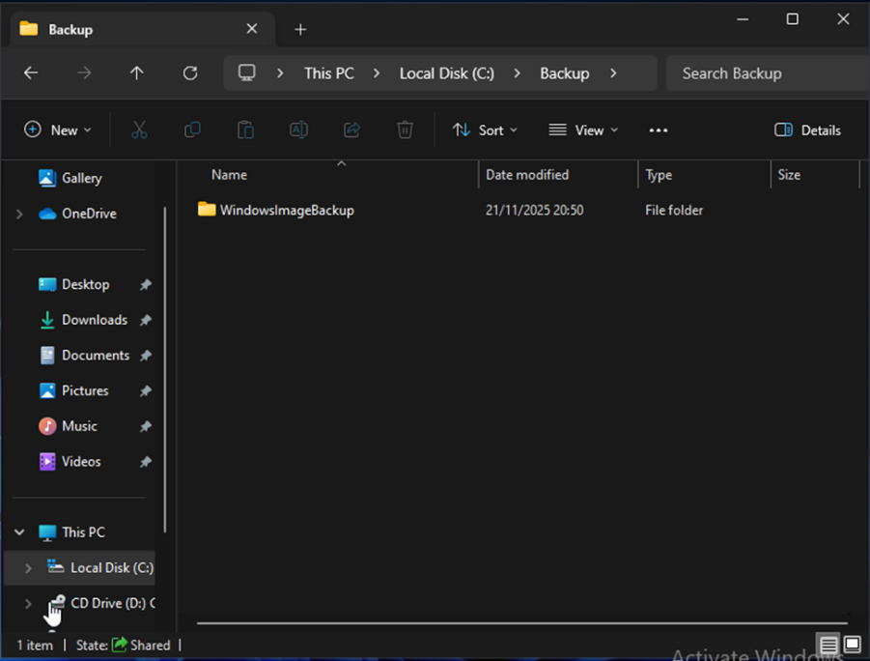
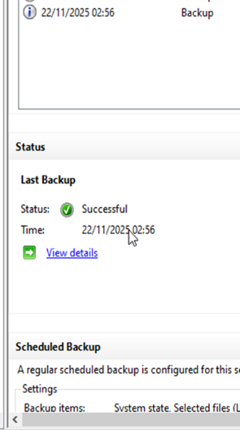
The selected backup storage location is then checked to confirm that the backup files have been successfully saved there.
Initial confirmation of a successful backup is provided at the completion of the process, where the system displays a success message along with the date and time of the backup.
Assessor’s signature |  | Date

